Ministry of Education and Science of Ukraine

**National Technical University**

**"Kharkiv Polytechnic Institute"**

**ELECTRICAL MACHINES**

**LECTURE CONSPECTUS**

on the Discipline «Electrical Machines»

for students of specials 141 – Electric power engineering,

electrical engineering and electromechanical engineering

by prof. Shevchenko Valentina V.

Kharkov – 2020

**Part 1**

**INTRODUCTION. TRANSFORMERS**

We begin to work on the course "Electric Machines", which consists of lectures, laboratories and practical exercises. The course is for one semester. During this semester, you must do one test work. At the end of our work will be a written exam.

I can give you some names of **the literature**.

For example:

1. Siddhapura K.R., Raval D. B. A Textbook of Electrical Machines. //Vikas Publishing, 2018, 872 p.

https://www.vikaspublishing.com/books/engineering/electrical-engineering/a-textbook-electrical-machines/9789325975620/

2. Siddhapura K.R., Raval D. B. AC Machines: (for Gujarat technological university) // Vikas Publishing, 2016, 232 p.

https://www.vikaspublishing.com/books/engineering/electrical-engineering/ac-machines/9789385879005/

### 3. Siddhapura K.R., Raval D. B. DC Machines and Transformers: (for Gujarat technological university) // Vikas Publishing, 2015, 256 p.

https://www.vikaspublishing.com/books/engineering/electrical-engineering/dc-machines-transformers/9789325990142/

# 4. [Rajput](https://www.google.com.ua/search?hl=ru&tbo=p&tbm=bks&q=inauthor:%22Rajput%22). A Text Book of Electrical Machines // Firewall Media, 2006, 1304 p.

https://books.google.com.ua/books?id=FLgMygrZDgEC&printsec=frontcover&hl=ru#v=onepage&q&f=false

5. Electrical machines. 2009, 102 p.

https://www.pdfdrive.com/electrical-machines-e151757.html

6. Charles A. Gross «Electric Machines». – Series: Electric Power Engineering Series. – CRC Press – 2006 – 466 р. ISBN 9780849385810 – CAT# 8581.

# 7. Jacek F. Gieras «Electrical Machines: Fundamentals of Electromechanical Energy Conversion». - CRC Press Textbook – 2016. – 434 p.

ISBN 9781498708838 - CAT# K24957

8. I. Boldea, L.N. Tutelea «Electric Machines: Steady State, Transients, and Design with MATLAB®» - CRC Press Textbook. – 2009. – 792 р.

ISBN 9781420055726 - CAT# 55720

9. Shaahin Filizadeh «Electric Machines and Drives: Principles, Control, Modeling, and Simulation». - 2013 by CRC Press Reference – 237 р.

ISBN 9781439858073 - CAT# K12709

10. Hamid A. Toliyat, Subhasis Nandi, Seungdeog Choi «Electric Machines: Modeling, Condition Monitoring, and Fault Diagnosis» – CRC Press Reference. – 2012. – 272 р. ISBN 9780849370274 - CAT# 7027

11. [D. P. Kothari](https://www.google.com.ua/search?hl=ru&tbo=p&tbm=bks&q=inauthor:%22D.+P.+Kothari%22), [I. J. Nagrath](https://www.google.com.ua/search?hl=ru&tbo=p&tbm=bks&q=inauthor:%22I.+J.+Nagrath%22) «Electric Machines». – Tata McGraw-Hill Education, 2004. – 834 р. ISBN 9780849370274 - CAT# 7027

12. D. P. [Kothari](https://www.google.com.ua/search?hl=ru&tbo=p&tbm=bks&q=inauthor:%22Kothari%22) «Electric Machines». – Tata McGraw-Hill Education – 2014. – 914 р.

13. A. Husain and H. Ashfaq «Electric Machines». – CRC Press Reference. – 2016. – [490](https://www.amazon.in/Electric-Machines-Ashfaq-Husain/dp/8177001663/ref=sr_1_1/260-6304356-8918465?s=books&ie=UTF8&qid=1529092849&sr=1-1&refinements=p_27%3AAshfaq+Husain) p.

14. [J.B. Gupta](https://www.goodreads.com/author/show/13818229.J_B_Gupta) «Theory & Performance of Electrical Machines». - Published by S.K. Kataria & Sons. – 2016. – 775 p.

15. Stephen J. Chapman «Electric Machinery Fundamentals». 5th Edition. – Published by S.K. Kataria & Sons. – 2014. - 775 p. ISBN-13: 978-0073529547

16. **Methodical instructions, control questions and calculation tasks for the discipline by V. Shevchenko** (2020) «Analysis of transformers and electrical machines constructions and calculation of their characteristics» you can take on the website:

http://web.kpi.kharkov.ua/elmash/286-2/

But I think you'd better use our lectures conspectus and the Internet to study specific issues.

**The objects of our course study** are transformers and electrical machines, which are the basis of electric power in various industries.

**The subject of this course** is electric machines, which are used in practice to convert one form of energy into another: mechanical to electrical (generator), electrical to mechanical (electric motors), and power transformers, which are used to convert the parameters of alternating current and voltage.

While studying the course "Electric Machines" we will consider the three topics: transformers, alternating current machines, DC machines.

Today we must conduct an entrance control to determine your knowledge.

Questions to test knowledge on the section "Transformers" are at the end of this section 1 (Part 1).__________________________________________________________

**At first we must repeat the basic laws that we need to study the course**

1. **Law of energy conservation –** Energy does not disappear anywhere and does not appear without a source **in the closed system**.

This is the general law for all the Universe.

2. **Law of electromagnetic induction (by Michael Faraday)**: if the conductor is placed in an alternating magnetic field, then it will create an electromotive force (EMF)



where *w* – is the number of the winding turns.

 – speed of change of magnetic flux.

**This low** is the most important for all electrical engineering.

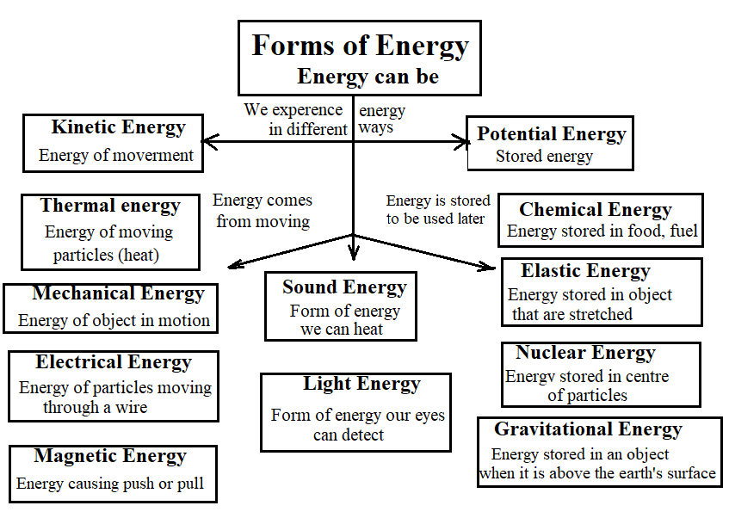

3. Let's repeat the laws of Kirchhoff and Ohm

1) **The first law of Kirchhoff**. The algebraic sum of currents in the electrical circuit node is 0.

2) **The second law of Kirchhoff**. The algebraic sum of EMF and voltage in an electrical circuit is 0.

3) **Ohm's law for a section of an electrical circuit** 

4**) Ohm's law for a complete closed electrical circuit** 

where: *E* *–* EMF of the voltage source, V; *I* *–* current in the circuit, A;

*R* *–* resistance of all external elements of the circuit, Ohm;

*r –* internal resistance of the voltage source, Ohm.

**In addition, you should know:**

**Active power** *P* = *m·U·I*·cosφ, W.

**Active power is needed** for work and for losses.

**Reactive power** *Q* = *m·U·I*·sinφ, var.

**Reactive power is needed** to create magnetic fields.

where *m* *–* is the number of phases,

*U –* phase voltage, V, *I*·*–* current, A, cosφ *–* power factor.

φ – the angle between current vector and voltage vector.

Inductive load *U* and *I* capacitive load *I* and *U*

The full power may be writing as

*S* = *m·U·I*, *VA* or , *VA*

**All** losses allocated in the form of **heat**. **Therefore, one CANNOT SAY “heat” losses.**

**Losses are**:

*–* **Electrical losses** occur when the current passes through the conductor. According to Joule's law, the losses powers are proportional to the current in the second degree *I*2*R,* where *R* – the resistance of conduction

*–* **Magnetic** losses are when magnetic flux passes through steel cores.

The main magnetic losses in steel are of **two types**: from eddy currents (Foucault currents) and from remagnetization (or from hysteresis).

The cores of transformers and machines are recruited from thin plates of electrical steel to reduce losses in steel (core assembly of thin plates = «sheektovka»). The thickness of the plates is 0.5 mm. These plates isolated with varnish or oxide skin on both sides.

*–* **Mechanical** losses – these are the losers from friction in bearings and air, and ventilation losses.

These losses are from friction in bearings and from friction about the air of the rotor that rotates. Also that is the ventilation losses.

*–* **Additional** losses – that are losses which are not taken into account before.

**1. TRANSFORMERS**

We begin to study transformers. Transformers are not electrical machines, because the form of energy does not change in them.

**Write and know!**

**Electrical machine** – it’s **electromechanic converter** that converts electrical energy into mechanical energy and vice versa, mechanical energy into electrical.

For all electrical machines the "**principle of reversibility**" works: any electrical machine can be both an engine and a generator.

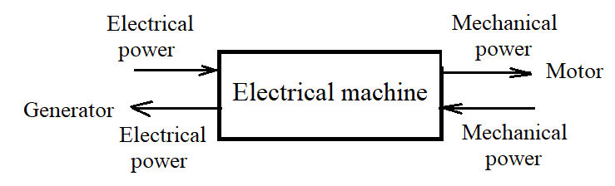

Fig. 1.1 – Electrical machine diagram

In transformers the parameters of electrical energy change only – value of current and voltage. But the physical processes in transformers are very similar to physical processes in asynchronous machines. Therefore, transformers are studied in the course of electrical machines.

In this way **Transformer** – It is a static **electromagnetic device**, which is designed to convert an alternating current of one voltage into an alternating current of another voltage, but of the same frequency.

Transformers **consist** of a core and windings. Let's draw a transformer.

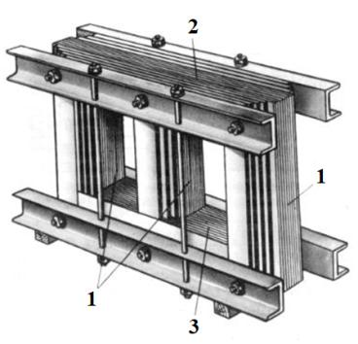

Fig. 1.2 – The magnetic circuit of a three-phase three-rod transformer:

1 – rods; 2 – overhead yoke; 3 – the lower yoke

Transformer core directs magnetic field. Therefore, the core of the transformer that conducts a magnetic also field is called the «**magnetic core**», fig. 1.3.

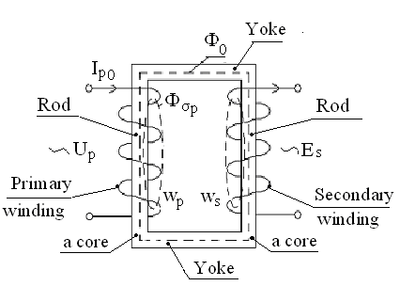 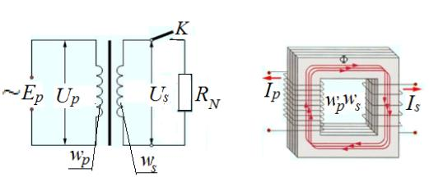

Fig. 1.3 –The transformer core and windings.

**The operating principle of transformer**

The alternating current is supplied to the primary winding.

Current creates an alternating magnetic field. The magnetic flux closes along the core and in the secondary winding induces electromotive force (EMF). It’s **mutual induction**.

The magnetic flux closes on itself. Therefore, in the primary winding, the flux also induces an EMF, which is called the EMF of self-induction (induction by itself).



 We divide the first equation by the second

_______________

 It’s **transformation ratio** of the transformer

When *ktr*<1 – a step-up transformer (less 1!)

When *ktr* >1 – a step-down transformer (more 1!)

*Ф* – magnetic flux, Weber (Web)

 – rate of magnetic flux change.

Now we will consider the **classification** of transformers

**Transformers are classified according to different characteristics:**

1. **Intended use**: power, measuring, special

Power transformers – are for the electrostations and for industrial enterprises.

Measuring transformers - are for measuring high currents and voltages. Current transformer and voltage transformer

Special transformers – are for the scientific research

**2.** **On the design of cores**: rod construction, armored construction, armored-rod construction and toroidal construction - in the form of a torus. This name is created from the shape of the geometric figure – torus.

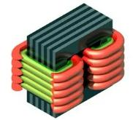 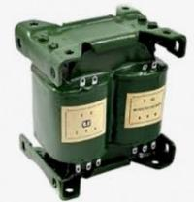 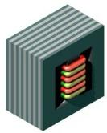 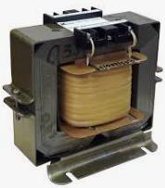

rod construction

armored construction

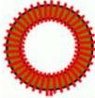 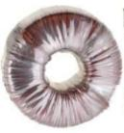 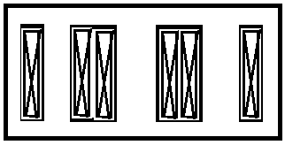

armored-rod construction

toroidal construction

of three-phase transformer

**3.** **Classification** **by winding design**: the concentric (one in the other) and the disc (or plates).

In the concentric design the low voltage winding is closer to the rod, inside. This is done for greater safety of workers; of three-phase transformer

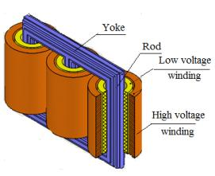 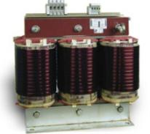 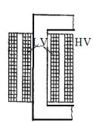 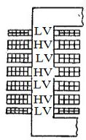

The concentric construction

The disc («plate») construction

**LV** – Low voltage

**HV** – high voltage

In the concentric design the low voltage winding is closer to the rod, inside. This is done for greater safety of workers

**4 Number of phases**: single-phase and multiphase (usually three-phase)

**5.** **Classification** **by cooling method**: **dry** (**air** cooling) and **with cooling by oil**.

Dry transformers (without oil) are produced up to 1600 kVA and with voltage up to 15,75 kV with natural cooling. The advantage of dry transformers is their fire safety.

|  |  |  |
| --- | --- | --- |
|  |  |  |
| Dry transformers  (with air-cooling) | Transformers with cooling by oil | |
| Construction **with**  expansion tank | Construction **without**  expansion tank |

6. **By the number of windings per phase**: with one winding, with two windings or with three windings.

Transformers with one winding per phase are **autotransformers.**

They are used to connect power transmission lines with different voltages. For example, it is 110 kV and 220 kV.

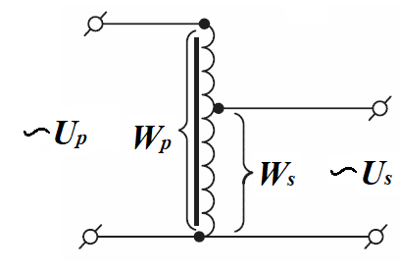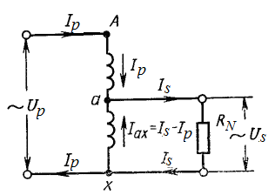

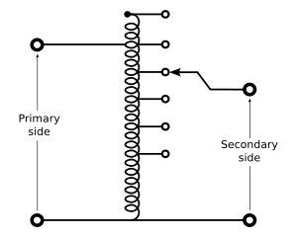

The transformation ratio of the autotransformer should be no more than 2-2.3

**In addition,** the small autotransformers are used in laboratories for regulation of voltage.

*In its turn*, the transformers with **three windings** per phase are:

– With one primary winding and two secondary windings for different voltages. (These are transformers with **three windings namely**);

– With one primary winding and two secondary windings for the same voltage (It is transformers with **split windings**).

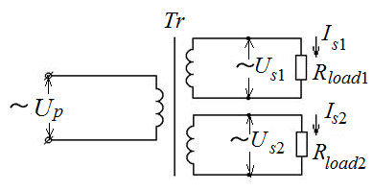 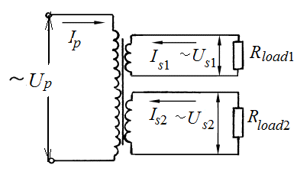

For transformers with **three windings *Us*1 ≠ *Us*2**

For transformers with **split windings *Us*1 = *Us*2**

The primary and secondary windings of three-phase two-winding transformers may be connected on the schemes «star-star» or «star – triangle (delta)». The most common connection schemes for transformer windings are shown in Table 1.1.

Table 1.1 - The most common connection schemes for transformer windings

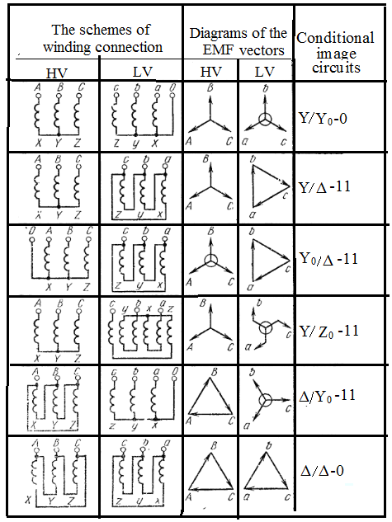

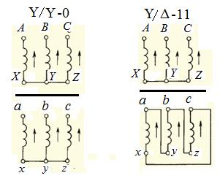

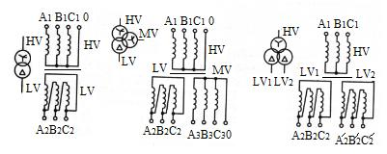

**Schemes** **of the connected transformers windings**

Three-phase windings of the transformer can be connected according to the schemes "star", "triangle (delta)" and "zigzag".

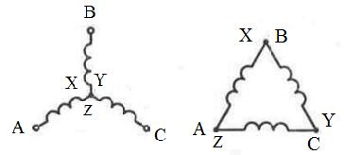

Connection diagrams of the transformer windings in the "star" and in the "triangle"

In the schemes «star » or «triangle (delta)» the angle between voltage vectors is 120 el. degrees. In all these schemes, the angle between voltage vectors is 120 el. degrees.

The scheme "**zigzag**" is used if it’s necessary that the angle between voltages vectors must be differ from 120 el. degrees

Now we have started using the "**zigzag**" scheme.

For example if the number of winding turns is the same, the angle between the vectors voltage will be 60 el.degr.

These were **schemes**.

But you need to know **the Groups of Connections** **Transformers Winding**.

You can receive different groups of winding of transformers.

**The winding group of connection** is determined by the shear angle between the linear voltage vectors of the primary and secondary windings.

To determine the winding group of connection, the high voltage vector sent for 12 hours, as the minute hand of the clock.

The beginning of the low voltage vector is connected to the beginning of the high voltage vector. The direction of the low voltage vector will show the **group** of windingconnections.

**The winding group of connection depends on**:

1) Of the number of the transformer phases.

Single-phase transformers have only first and sixth groups. Three-phase two-winding transformers may be having 12 groups.

2) From winding connection diagram.

3) From marking the ends of the windings.

4) From winding direction of windings.

In industry, only two groups of winding connections are used – zero and eleven.

If the winding connection schemes are the **same**, the group will be 0, if **different** – it is 11.

**The designation of the transformers is shown in Table 1.2**.

Table 1.2 – Designation of transformers

|  |  |  |
| --- | --- | --- |
| **Conformity of conventional symbols for the types of cooling systems adopted by GOST, CMEA and IEC.** | | |
| **Conditional type of cooling** | | **Type of transformer cooling system** |
| **GOST (in Russian)** | **CMEA and IEC** |
| **Dry transformers** | | |
| С | AN | Natural air cooling with open design |
| СЗ | ANAN | Natural air cooling with protected design |
| СГ | Natural air cooling in hermetic design |
| СД | ANAF | Air cooling with forced air circulation |
| **Oil Transformers** | | |
| М | ONAN | Natural circulation of air and oil |
| Д | ONAF | Forced air circulation and natural oil circulation |
| МЦ | OFAN | Natural air circulation and forced oil circulation with non-directional oil flow |
| НМЦ | ODAN | Natural air circulation and forced circulation of oil with directional oil flow |
| ДЦ | OFAF | Forced circulation of air and oil with non-directional oil flow |
| НДЦ | ODAF | Forced circulation of air and oil with a directional oil flow |
| Ц | OFWF | Forced circulation of water and oil with non-directional oil flow |
| НЦ | ODWF | Forced circulation of water and oil with a directional oil flow |

For example, the TONAN -1000-110/10 U3 or TONANP-1000-110/10-U3.

TONAN: «T» – three-phase; ONAN – with natural circulation of air and oil.

«P» – protected; 1000 – 1000 kVA, 110/10 – 110 kV on 10 kV, *U* – temperate climate, 3 – installation of a transformer in the workshop without additional conditions.

1 – transformer placed on the street. 2 – over the transformer you need to install a canopy. 4 – transformer needs in special conditions

For transformers with oil cooling systems using nitrogen or carbon dioxide in the surge tank to protect the oil from oxidation by air (“protected”), add the letter “*P*”.

Now such transformers sometimes do without an expantion tank, Fig. 1.2.

Such transformers are performed in an airtight version with a full filling of the tank with oil. Oil expansion during heating will be due to the movement of the ribs on the tank (

**Consider the design of the oil transformer**.

Tanks of power transformers are made of sheet steel.

Oil in transformers is used **for insulation and cooling**. The oil ages during the operation of the transformer and loses its initial insulation properties. It is affected by oxygen, water, dirt and heat, Fig. 1.4.

The windings of transformers are made of electrical copper or aluminum of rectangular or circular cross-section. Cylindrical and screw windings are often used. They are separated from the core, from each other and from the walls of the tank by cylinders of insulating material (Bakelite).

**You must understand** why the voltage is increased at power plants before being transferred to consumers.

! **The voltage is increased in order to reduce the current.**

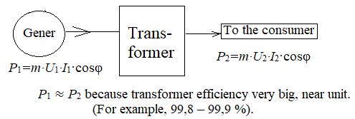

Fig. 1.3 – Purpose of the transformer

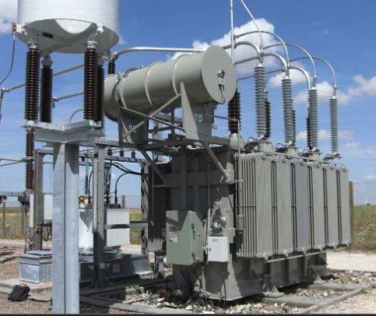

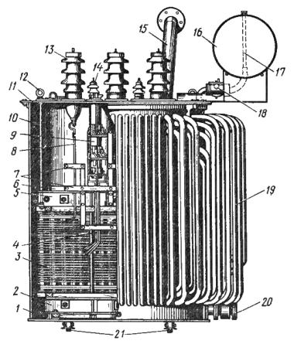

Fig. 1.4 – Three-phase power transformer with a capacity of 1000 kV•A with oil cooling:

1 – the tank; 2, 5 – the lower and upper yoke beams; 3 – winding HV;

4 – adjusting bends; 6 – magnetic core; 7 - wooden boards; 8 – tap from the winding HV;

9 – the switch; 10 – lifting pin; 11 – cover; 12 – lifting ring; 13 – input of HV;

14 – input LH; 15 – an exhaust pipe; 16 – expansion tank; 17 – oil indicator;

18 – the gas relay; 19 – circulation pipes; 20 – oil drain cock; 21 – rollers.

*P*1*=m·U*1*·I*1·cosφ ≈ *P*2*=m·U*2*·I*2·cosφ

*P*1 ≈ *P*2 because transformer efficiency very big, near unit.

(For example, 99,8 – 99,9 %). Therefore, *U*1*·I*1≈ *U*2*·I*2.

If in transformer the voltage *U*2 increase by 10 times, the voltage *U*2 will become 10 times bigger than *U*1. In this case, the current *I*2 will also decrease 10 times.

It’s very important, because according to **Joule's law**, copper losses (electrical losses) will decrease by 100 times. In addition, if you reduce the current, then you can reduce the cross-section of the conductors through which electricity is transmitted to consumers.

**Joule's law** *Pel*=*m·I*2·*R* or according to the **Joule-Lenz law** *Pel*=*m·I*2·*R·t.*

Voltage has standard values: 6(10) kV, 35 kV (in some regions where the population lives densely), 110 kV, 220 kV, 330 kV, 500 kV, 750 kV, 1150 kV.

In Ukraine, the maximum voltage is 750 kV.

Russia is currently building a voltage transmission line by 2500 kV.

Before approaching the consumer, the voltage is reduced gradually, by "steps":

750 kV→500 kV→110 kV→6(10) kV→0,4 kV

**TRANSFORMER TESTING**

**Transformer tests after repair**

After repairing the transformer, it is necessary to carry out tests. It is almost impossible to test the transformer in nominal mode, because it is impossible to create a rated load during testing. Therefore, transformers are tested in idle and laboratory short circuits. These experiments do not require a lot of equipment. They can be carried out at the plant to test new transformers. Experiments can be carried out at lowering stations as well. Most importantly, these experiments do not require a lot of equipment. The nominal parameters of the transformer can be calculated from the results of two that experiments.

To study these issues, we will consider "a transformer that lowers the voltage - a step-down transformer" and transformers with reduced parameters ("reduced" transformer).

**Reduced transformer**

Reduced transformer is a transformer whose secondary winding parameters are changed in accordance with the parameters of the primary winding.

For this transformer shown, the transformation ratio of **reduced transformer is one** (is unity).

The parameters of the ***reduced transformer*** are indicated by a stroke (штрих).

The use of the given transformer allows **to simplify the calculations**.

Instead of studying the magnetic connection between the windings using Maxwell's equations, we can imagine the transformer as an electrical circuit and use Ohm's law and Kirchhoff's laws.

Calculations of the nominal parameters of the transformer are made for the step-out transformer. After carrying out the calculations, the real parameters of the transformer are obtained by means of a conventional transformation ratio.

**As we said, after manufacture or repair, the transformer must be tested.**

It is difficult to test in nominal mode, usually there is **no load** for the transformer

**Therefore, for the study of transformers, two experiments are conducted – an idling test and a laboratory short circuit test.**

These experiments do not require a large amount of equipment. It is important. They can be carried out at the plant for testing new transformers and at transformer stations.

Therefore, all rated parameters of the transformer can be calculated from the results of these two experiments.

Now consider **the transformer idle experience**. Let's draw the experimental scheme and the **scheme of substitution**, fig. 1.5.

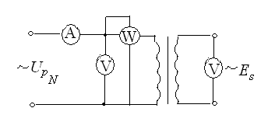 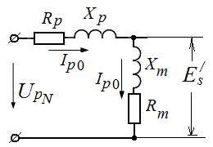 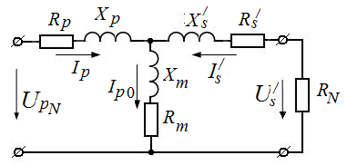

Fig. 1.5 – The experimental scheme (*a*) and the scheme of substitution (*b*)

in the experience of idling

**In this experiment (when idling) we can determine the following parameters, Fig. 1.5**:

1) **Losses of steel power** (magnetic losses) *P*0= *Pmag*.

It is constant losses; they do not depend on the load

2) **Power factor** in the experience of idling

;

*m* – number phases; *UpN* – nominal voltage of prime winding;

*Ip*0 – the current of the idling experience (**magnetization current**)

3) **Magnetizing current** *Ip*0 – the current of the idling experience;

4) **Parameters** of the transformer replacement scheme *xp, Rp*, *xm, Rm*;

– total resistance of the equivalent scheme on the idling mode, Ohm,

*Z0*= *Rp*0+ *jxp*0 or ; ;

– active resistance of the equivalent scheme on the idling mode, Ohm,

*Rp*0= *Rp*+*Rm*; ;

– reactive resistance of the equivalent scheme on the idling mode, Ohm,

*xp*0= *xp*+*xm* .

In the **experience of idling,** we can determine only these parameters. But we have to determine separately every one.

5) *Es/* – To determine the reduced value of the secondary winding EMF, it is necessary to construct a vector diagram. The value *Es/* can be obtained only graphically.

We construct a vector diagram from the equations:



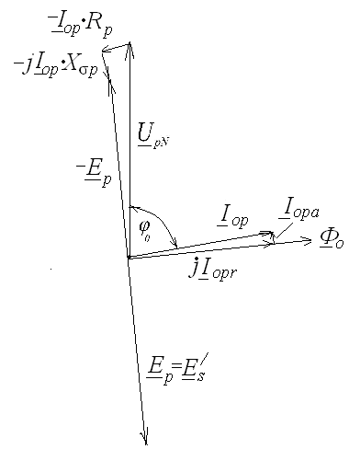We transform the first equation:

.

Than we choose a scale for voltage, EMF and current, and construct a diagram, fig. 1.6.

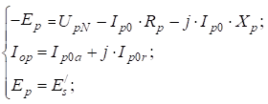

More from the experience of idling, we cannot determine anything.

Fig. 1.6 *–* Vector diagram of

the transformer in the idling mode

**Therefore, we carry out testing of the transformer in the mode of laboratory short circuit.**

Let's draw experimental scheme and scheme of substitution, fig. 1.7.

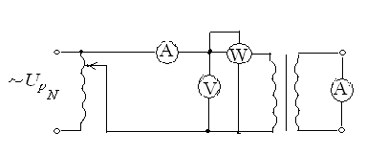 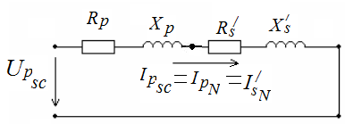

*a* *b*

Fig. 1.7 – Experimental scheme (*a*) and scheme of substitution (*b*)

in the laboratory short circuit mode

**We determine in the laboratory short circuit mode**:

1. Nominal electric power losses *PK* – by wattmeter. Electrical losses *PK* in the transformer windings are variable and depend on the load, on the current. In the laboratory short-circuit test, we determine them at the nominal values of the currents in the primary and secondary windings. Therefore, this current determines the rated parameters.

2. The transformer power factor on the laboratory short circuit mode,

.

3. We define an important factor – **short-circuit voltage** ***uk,*** %**.**

.

*Uрk* – the voltage laboratory short circuit mode – by voltmeter, *V*.

*UpN* – the rated voltage of primary winding.

For determining the voltage *Uрk* we increase the voltage from zero until on the ammeters, which are installed in the primary and secondary windings, the currents will equal the rated currents.

Remember, the **short-circuit voltage** *uk* is measured in percent!

The value of the short-circuit voltage *uk* is indicated in the transformer's passport data.

4. Also we define the parameters equivalent circuit transformer on the laboratory short circuit mode:

- Total resistance equivalent circuit on the laboratory short circuit mode, Ohm,

,

where – **Active resistance** of the equivalent circuit on the laboratory short circuit mode , Ohm;

– **Reactive resistance** of the equivalent circuit on the laboratory short circuit mode

*,* Ohm.

Parameters of the transformer equivalent circuit in the nominal mode.

Therefore:

– Active resistance of the transformer primary winding equals the given value of reduced active resistance of the secondary winding. Ohm,

**;

– Reactive resistance of the transformer primary winding equals the given value of reactive resistance reduced secondary winding, Ohm,

**;

After we have determined the active and reactive resistance of the primary winding, we can determine the active and inductive resistance of the magnetic circuit of the transformer:

– Similarly the resistance of the magnetizing circuit of the transformer, Ohm,

**; **.

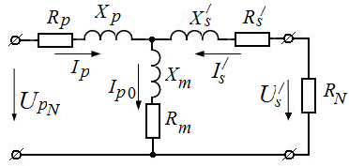

Fig. 1.8 – Scheme of substitution transformersin the laboratory short circuit mode

**Conditions for Including Transformers for Parallel Operation**

**If two transformers need to be switched to parallel operation, then the following conditions must be met**:

1. Transformers must have the same connection groups: "**0" or "11".**

This is the most **important** condition.

2. Transformers must have the same transformation ratios

*Ktr*1 = *Ktr*2 = .... = *Ktri*,

where *i* – it is the number of transformers.

3. Transformers must have the same **short-circuit voltage**: *uk*1=*uk*2 = ... = *uki*.

You can install transformers in parallel that differ in power by **one step**.

The transformer capacities have definite values: 100, 125, 160, 200, 250, 400, 630, 1000, 1250, 1600 kVA and other.

If the powers of the transformers are different, the short-circuit voltage must be others. For a transformer that has less power, the short-circuit voltage must be greater.

Determine **the transformer coefficient of performance** (COP) in the nominal mode from the known values of power losses in the idling mode and at the laboratory short circuit mode,

,

where *Р*0, *W* – power losses on the idling mode, which are the magnetic losses in the transformer magnetic core, *Р*0 = *Рmag*=const;

 – the load factor of the transformer,

.

At the nominal loading = 1. (equally)

**The transformer maximum COP is achieved when the constant and variable power losses are equal**. The load value (in parts of the nominal capacity) at which the COP of the transformer are maximum:

.

Then the maximum transformer COP can be calculated,

.

Let's construct the dependence of the efficiency of the transformer on the load factor (the load value) η = *f*(β*Is*) in the relative units (r.u.), fig. 1.9.

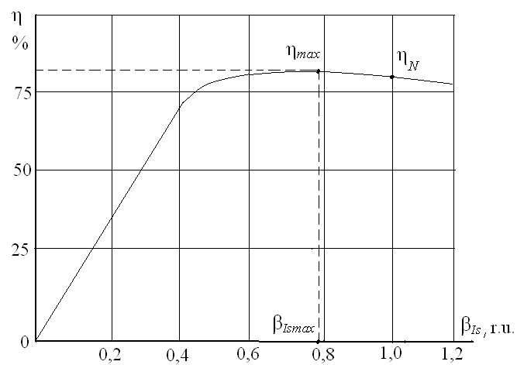

Fig. 1.9 – The dependence of the efficiency of the transformer on the load factor

The maximum value of the efficiency of the transformer is at the load value β*Is* = 0.75–0.8. Transformers at enterprises usually work with a non-nominal power. Therefore, such a decision is correct.

**External (load) characteristic of the transformer *Us= f*(*Is*)**

The type of external characteristics of the transformer is determined not only by the magnitude of the load, but also by its character. With an increase in the active and active-inductive load, the voltage of the transformer decreases, with a capacitive and active-capacitive load, the voltage of the transformer increases, fig. 1.10.

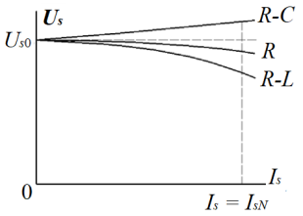

Fig. 1.10 – External (load) characteristic of the transformer

**Transformer performance (Operating transformer characteristics)**

The transformer performances are the dependence of the efficiency, power factor, primary current and secondary winding voltage (load) on the load current in the secondary winding. A typical view of the performance is shown in the fig. 1.11.

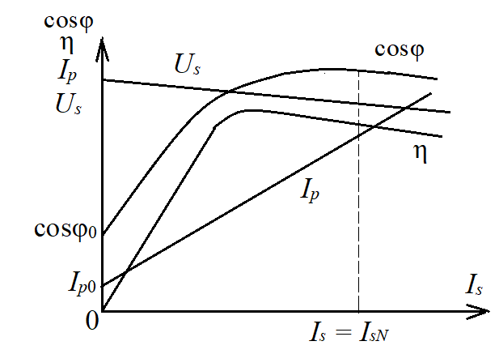

Fig. 1.11 – Operating transformer characteristics

**Overvoltages in Transformers**

Overvoltages occur for various reasons:

1) Overvoltage occurs when switching is performed in transformers. They are usually not dangerous.

2) Emergency overvoltages arise from various accidents. For example, short circuits in windings, destruction of insulating envelopes that cover the steel sheets from which the core of the transformer is being assembled (“fire in steel”). Typically, these overvoltages are disabled by the protection system.

3) Atmospheric overvoltages usually occur during a storm. A lightning strike into a power line causes the appearance of a “wave” of high voltage. This voltage goes to the transformer. A large voltage appears between the turns of the windings, this leads to a breakdown of the insulation of the conductors, to an accident. To protect against atmospheric overvoltages, they put protection - lightning protection.

These are the most dangerous overvoltages.

**AUTOTRANSFORMERS**

Autotransformers are classified as special-purpose transformers.

In electromagnetic energy converters (transformers), the transfer of energy from one winding to another is carried out by a magnetic field, the energy of which is concentrated in the magnetic circuit. In autotransformers, energy is transmitted both by a magnetic field and by electrical connection between the primary and secondary windings, fig. 1.12.

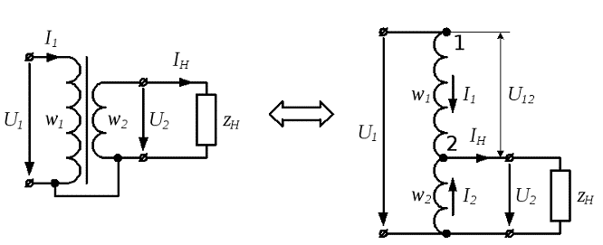

Fig. 1.12 – Scheme of a conventional transformer and autotransformer

If it is necessary to change the voltage within small limits, then the easiest way is to make not two-winding transformers, but one-winding ones, which are called "autotransformers".

Autotransformers differ from transformers in that their low voltage winding is part of the higher voltage winding, that is, the circuits of these windings have not only magnetic, but also electrical connection.

The main difference between an autotransformer and a conventional transformer is the absence of a second coil and a second core leg. The role of the secondary windings is performed by separate groups of turns of a single coil. These groups do not require additional separate electrical insulation, Fig. 1.13.

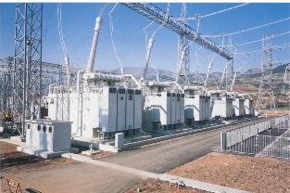Autotransformers are single-phase and three-phase. Sometimes in three-phase networks, three single-phase transformers are installed, which are connected with a star or delta, table 1.3.

Fig. 1.13 – High voltage autotransformers

Table 1.3 – Diagram of three-phase autotransformers

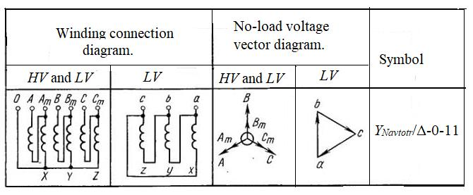

Depending on the inclusion of the autotransformer windings, an increase or decrease in voltage can be obtained.

Autotransformers are advisable to use for a slight decrease or increase in voltage, when a reduced current is set in the common part of the winding for both autotransformer circuits.

This allows for thinner wire wrapping and saves non-ferrous metal. At the same time, the consumption of steel for the manufacture of a magnetic circuit decreases, the cross section of which is less than that of a transformer.

**Disadvantages of autotransformers**

1) The disadvantage of the autotransformer is the need to isolate both windings for a higher voltage, since the windings are electrically connected.

2) The operation of three-phase power transformers is allowed with a transformation ratio of no more than 2.0-2.3. For example, 220/110 kV is allowed and 220/750 kV is not allowed.

**Laboratory autotransformers (LATRs)**

Autotransformers are also used in low-voltage networks as laboratory low-power voltage regulators (LATR). In such autotransformers, voltage regulation is carried out by moving the sliding contact along the winding turns.

Laboratory controlled single-phase autotransformers consist of a ring-shaped ferromagnetic magnetic circuit wrapped with one layer of insulated copper wire.

On the surface of the winding, stripped of insulation, there is a narrow track along which a brush or roller contact is moved to obtain a continuously adjustable secondary voltage ranging from zero to 250 V.

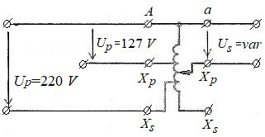 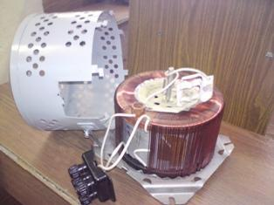

Fig. 1.14 – Scheme and appearance of LATR

In the adjacent LATR turns, no turn short circuits occur, since the network currents and loads in the autotransformer winding are close to each other and directed oppositely.

LATRs are manufactured with a rated power of 0.5; 1.0; 2.0; 5.0; 7.5 kVA.

**Questions to the Part 1**

**Transformers**

1. Formulate the law of energy conservation

2. Formulate the lawof electromagnetic induction

3. Write down the equations for determining active power, reactive power and full power. Why do we need active and reactive power?

4. What are the losses in electric machines and transformers? In what form do they stand out?

5. Why are the cores of transformers and electrical machines recruited from thin plates of electrical steel?

6. Why transformers studied in the course of electric machines? What is it «transformer»?

7. What are the main elements of the transformer? How does a transformer work?

8. What is it «transformer»? How to calculate the transformation ratio of a transformer?

9. What are the parameters used to classify transformers? What are the designs of transformer cores?

10. What are the designs of transformer windings? How do the number of phases and the number of windings per phase classify transformers?

11. How to classify transformers by cooling?

12. What schemes can use to compound three-phase transformer windings?

13. Define the term “transformer winding compound group”. What groups of compounds used in industry?

14. What indicators determine the connection group of the transformer windings?

15. What experiments (tests) conducted for the determination of rated parameters of transformers?

16. What is a "reduced transformer”? Why its use and as its indicated on the diagrams?

17. What parameters can be determined in the idle experiment of the transformer?

18. What parameters can be determined in the experiment named «laboratory short circuit»?

19. What are the conditions for switching on transformers for parallel operation on one electrical system?

20. What to calculate the efficiency of the transformer? How to determine at what load the transformer efficiency will be maximum?

**Part 2.**

**General questions of the alternating current machines theory**

We know that an electric machine is an electromechanical converter.

At the first lection we said that **all** electric machines can work only an engine (motor) and a generator. **This is the principle of reversibility of electrical machines:**

The engine converts electrical energy into mechanical energy. The generator converts mechanical energy into electrical energy.

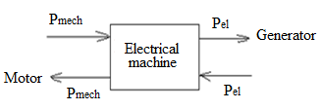

Fig. 2.1 – The principle of reversibility of electric machines

Consider AC machines. They are asynchronous and synchronous. Asynchronous machines mean "not synchronous".

AC machines consist of two main parts: the fixed part - stator; the moving part (the rotating part) is a rotor.

The stators of asynchronous and synchronous machines are the same.

The stator consists of a frame (housing) (1), the stator core (2) and the windings (3).

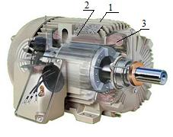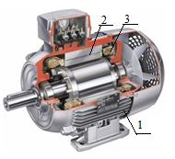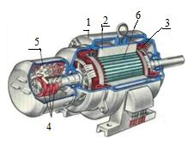

*a b c*

Fig. 2.2 – Asynchronous motors with short-circuited (*a, b*) and phase rotors (*c*)

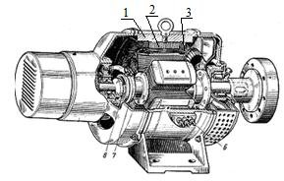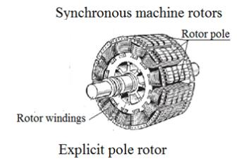

Fig. 2.3 – Synchronous motor with explicit rotor and explicit rotor of synchronous motor

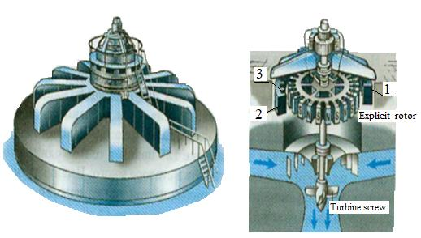 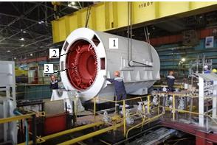

Hydro-generator with explicit rotor Stator of the turbogenerator with

an implicit rotor

Fig. 2.4 – Hydro-generator and stator of the turbogenerator

The core with windings is fixed in a frame. The frame consists of a housing with legs, a terminal box and bolts for transportation. The bolt for transportation uses for cars of small and average weight. Electric current is supplied to the stator winding, the ends of which are in the terminal box.

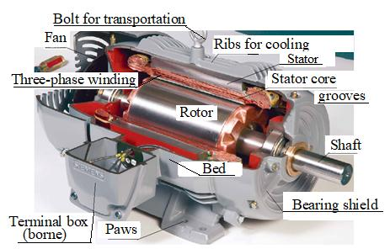

Fig. 2.5 – Asynchronous machine

The stator core is assembled from thin plates of electrical steel. This is done to reduce power losses in steel. The thickness of the plates is 0.5 mm (at a frequency of 50 Hz). On both sides the plates are covered with varnish or oxide film.

**Stator winding of AC**

The winding is connected in a "star" or "triangle". In the core of the stator make grooves, which are usually three-phase winding.

Usually 6 grooves are required for laying a three-phase winding. But there are always more of them, because the winding in AC machines is made distributed.

In this case, the beginning and end of each phase are placed not in one groove, but in several grooves (2-5 grooves).

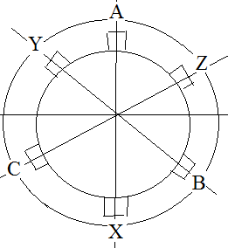 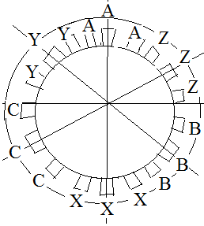 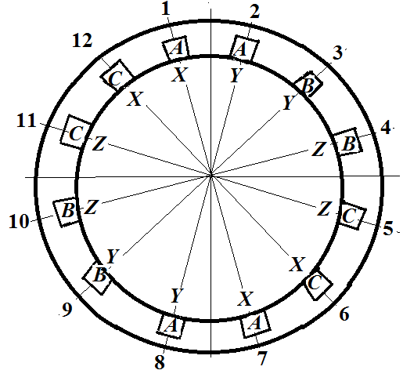

*a b c*

Fig. 2.6 – Stator core with grooves for laying:

*a –* diametrical and concentrated winding (*zs* = 6);

*b* – single-layer distributed winding (*zs* = 18);

c – two-layers of distributed winding (*zs* = 18)

Number of grooves per pole and phase:

 usually.

where *Zs* – number of stator grooves; *p* – number of pole pairs;

*m* – the number of phases.

**The presence of harmonics in the stator current**

Only the first harmonic of the current is needed to create a magnetic field in the air gap of AC machines. However, higher harmonics appear in the current because the winding lies in the grooves. Higher harmonics need to be fought. It is necessary to struggle with such harmonics.

**Consider ways to reduce higher harmonics:**

ν = 1 – the first (working) harmonic;

ν = 2*n* (*n*=1, 2, 3, ...) – in a car with three-phase symmetrical currents there are no paired harmonics of currents.

ν = 3*k*, where *k* = 1, 3, 5, …. These harmonics can be destroyed by connecting in a star pattern;

ν = 11, 13, 17, 19 … – we neglect these harmonics. They have small amplitudes, inversely proportional to the harmonic numbers. For example, in the 11-th harmonic the amplitude is equal to 1/11 compared to the amplitude of the first harmonic.

The basic problem is ν = 5 and 7, and these harmonics must be reduced.

To do this, the turns of each phase must be placed in several grooves (*qs*). This winding is called "distributed".

If the stator winding is two-layer, then in addition to the distribution should use abbreviations. This is something to keep in mind.

The reduction and distribution of the stator winding reduce the first EMF harmonic. For the first harmonic - it's bad, but the shortening and distribution allows you to remove the 5th and 7th harmonics, clear the first harmonic, and its shape becomes better.

The winding factor (*KWν*) shows how much the EMF of the shortened and distributed winding decreases compared to the diametrical and concentrated winding.

**The winding pitch in the grooves y is indicated.**

The pole division τ is the number of stator slots belonging to one pole of the machine τs = zs/2p, where zs is the number of stator grooves;

p - is the number of stator pole pairs (2p - is the number of stator poles).

The number of stator poles is determined by how the winding fits into the grooves. That is, the number of stator poles is determined using the winding circuit.

In the diametrical winding step *ydiam*=τ*s*.

In the shortened winding, the step is equal to ***yshor*= β∙τ*s***, where **β** — winding pitch reduction ratio (relative stator winding pitch).

Usually calculate the winding coefficients for the 1st, 5th and 7th harmonics:

**,

where *Кp*.ν – distribution coefficient which explains the decrease in the EMF of the

ν-th harmonic of the distributed winding compared to the EMF of the concentric winding,

;

*Кd*.ν ‑ the reduction factor takes into account the decrease in the EMF of the ν-th harmonic of the reduced winding, compared with the EMF of the diametrical winding,

**.

The winding distribution is used always. The winding reduction is used only for two-layer stator windings. Single-layer windings are used for small machines. Typically, two-layer windings are used for large AC machines.

The first harmonic of the EMF (ν=1) for the shortened and distributed stator winding is:

, В

where – winding coefficient of the first (working) harmonic.

**! Always!**

The value of KW1 for the reduced and distributed winding is always less than one. Therefore, in AC machines, in which the distribution and reduction of the step of the stator winding is applied, the value of the first (working) harmonic of the EMF is less than in machines with diametrical and concentrated windings.

This is done to improve the shape of the circular rotating magnetic field by reducing the effect of higher harmonics (5th and 7th harmonics).

Construct a single-phase two-layer reduced stator winding with the following parameters, Fig. 2.7: *m*=3, *Zs*=18, *p*=1 (machine with one pair of poles).

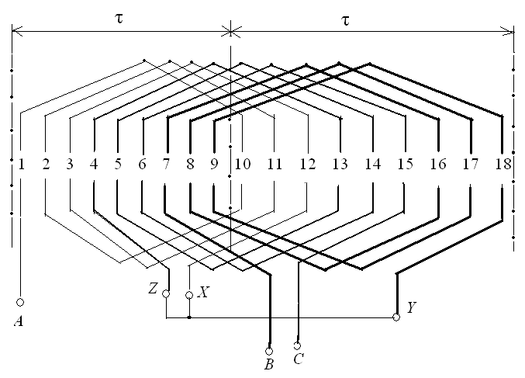 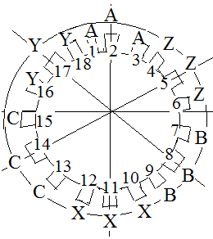

Fig. 2.7 – Scheme of a single-layer distributed stator winding

**Construction of a two-layer reduced stator winding**

Construct a two-layer, shortened and distributed stator winding with parameters: *m*=3, *Zs*=24, *p*=2 (four-pole machine) with reduction β=5/6.

**Conclusion: the winding circuit determines the number of stator poles**.

τ*s*=*zs*/2*p=* 24/4=6; τ*s*= *ydiam*=6; step on the grooves *yshor*=*ydiam*\*β = 6∙5/6=5.

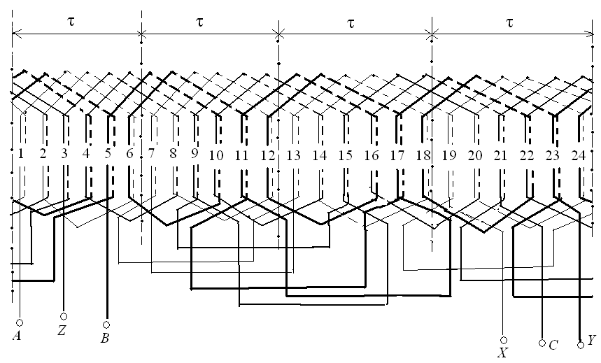

Fig. 2.8 – Scheme of three-phase winding of an alternating current machine

In fig. 2.9. a two-layer shortened and distributed stator winding is constructed, which has parameters: *m*=3, *Zs*=12, *p*=1 (2-poles machine) with reduction β=5/6.

Step along the grooves of the diametrical winding τ*s*=*zs*/2*p=* 12/2=6 τ*s*= *ydiam*=6.

Step along the grooves of the reduced winding: *yshor*=*ydiam*\*β = 6∙5/6=5.

This field is created by three-phase symmetrical currents of the stator winding. A rotating circular magnetic field rotates in the air with a velocity ***ns***.

A circular rotating magnetic field is the total field from all currents of the stator winding. The maximum sum of these fields rotates in the air with speed



where *fs* – current frequency, (*fs* = 50 Hz); *p* – number of pole pairs.

The speed ns is called "**synchronous speed**".

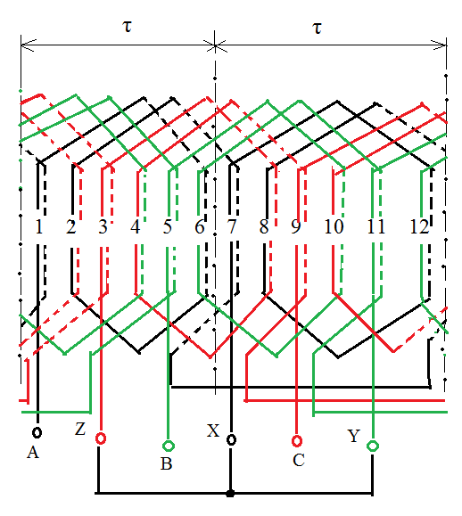

Fig. 2.9 – A two-layer stator shortening and distribution windings

**Creating a circular rotating magnetic field**

The magnetic field of the stator rotates with a synchronous frequency in all AC machines: in asynchronous and synchronous machines.

These machines differ only in the design of the rotor.

**Questions to the Part 2**

**General questions of the alternating current machines theory**

1. State the principle of reversibility of electrical machines. In what modes can electric machines work?

2. What are AC machines? What are the main parts they consist of?

3. Describe the design of the stators and rotors of AC machines.

4. Why the windings of the AC machines stators made distributed and shortened?

5. Describe ways to deal with the higher harmonics of the currents in the AC machines.

6. Describe ways to deal with the harmonics of the currents number 5 and 7 in the AC machines.

7. What types of windings can shorten? Why shorten the stator windings of AC machines?

8. How can one calculate and what does the stator winding distribution coefficient of an AC machine show?

9. How can one calculate and what does the stator winding shortening factor of an AC machine show?

10. What does the winding coefficient of the stator winding of an AC machine show? How to calculate it?

11. How to create a circular magnetic field that rotates? How fast does this field rotate?

12. What is the difference between stators and rotors of asynchronous and synchronous machines?

13. What is the difference between stators of asynchronous and synchronous machines?

14. What is the difference between rotors of asynchronous and synchronous machines?

15. What are the rotors designs of asynchronous and synchronous machines?

**Part 3.**

**Asynchronous machines**

Before the asynchronous machines were used only in engine mode, as motors. Currently, asynchronous machines are also used in the generator mode. For example, asynchronous generators are often installed on wind farms.

The stator design of the asynchronous machine was considered earlier.

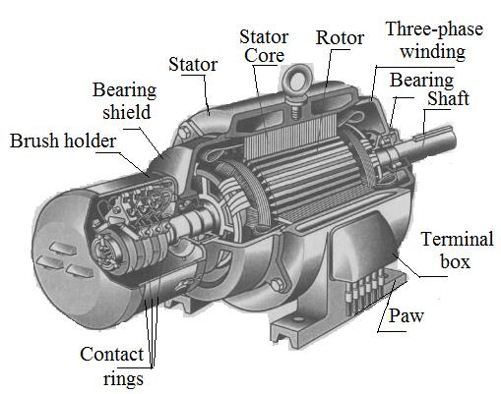

Rotors of asynchronous machines are of **two types**: closed-loop and phase.

But in both designs, the rotor winding is always short-circuited.

Rings that close the rotor windings. Deep grooves. Double squirrel cage grooves

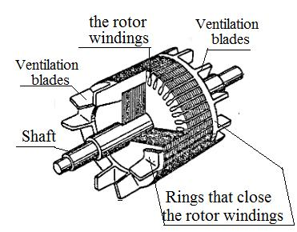 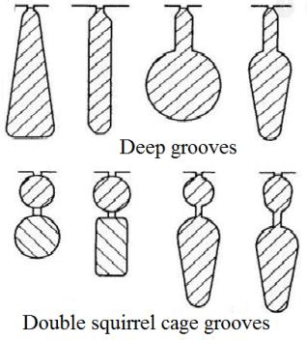

Rotor Groove Shape

The short-circuited rotors are very simple and reliable. The winding of the rotor is made of molten aluminum or copper, which is poured into the grooves of the rotor core. At the same time, the rings are cast from both sides of the rotor core. These rings short the rods of the rotor winding. A closed system is obtained.

Currently, the rotor winding began to be made of copper. Copper has less resistance than aluminum, so the efficiency of asynchronous machines has become larger. Previously, copper could not be poured so that the rods of the windings were intact, without ruptures. (Раньше медь нельзя было заливать так, чтобы стержни обмоток были целыми, без разрывов.) Copper very quickly crystallizes, and breaks formed in the rods.

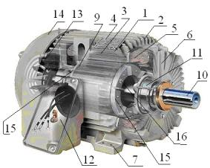 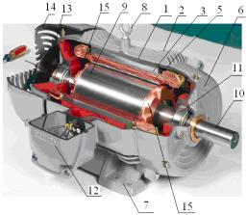 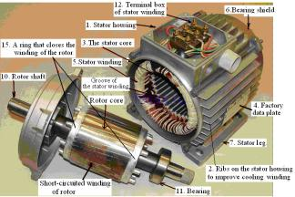

*a b c*

Figure 3.1 – Asynchronous machine

a – asynchronous machine with aluminum winding of the rotor;

b – an asynchronous machine with a copper winding of the rotor

c – Asynchronous motor series AIR

1. Stator body(housing). 2. Ribs on the stator housing to improve cooling. 3. The stator core.

4. Factory data plate. 5.Stator winding. 6.Bearing shield. 7. Stator legs.

8. Bolt for transporting the machine. 9. Rotor with short-circuited winding. 10. Rotor shaft.

11. Bearing. 12. Terminal box of stator winding. 13. Fan.

14. Fan protection cover. 15. A ring that closes the winding of the rotor. 16. Balancing weights.

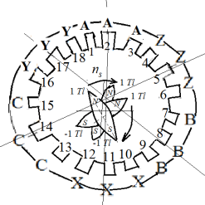

**The operating of principle of asynchronous motor.**

Three-phase alternating current is applied to the stator winding. Current creates a **circular magnetic field**, which rotates at a speed

 rpm.

Fig. 3.2 – Stator AC

This field, which rotates, is variable for the stator winding. According to the law of electromagnetic induction, the magnetic field in the conductors of the rotor winding induces an electromotive force (EMF).

Rotor conductors connected to rings. Therefore, a current appears in the conductors of the rotor. The magnetic field created by the rotor current interacts with the field of the stator current. The torque is generated; the rotor starts to rotate. The rotor catches up the stator field but cannot catch up a little behind.

The magnitude of the lag is characterized by a coefficient called "slip"

, r.u. (relative units) or .

For all asynchronous motors, the slip at the start is unit. Normally, the nominal slip *sN* is in the range of 2–8%. The rotor cannot catch the stator field, because the stator field for the rotor will become constant, and the EMF will not be induced in the rotor winding. Therefore, the machine is called asynchronous - not synchronous.

Consider the limits of slip:

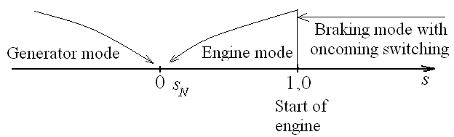

Fig. 3.2 – The limits of slip

Engine mode. Generator mode. Braking mode with oncoming switching

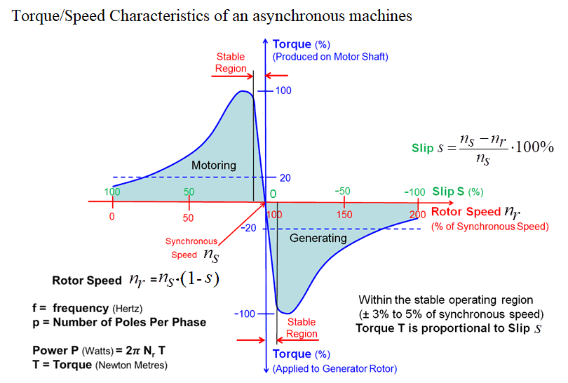

**Start of an asynchronous motor**

At start up asynchronous motors have two drawbacks:

1) There is a large inrush current. *Istar*=5–8 *IN*.

2) A small starting torque is created that is less than the rated torque.

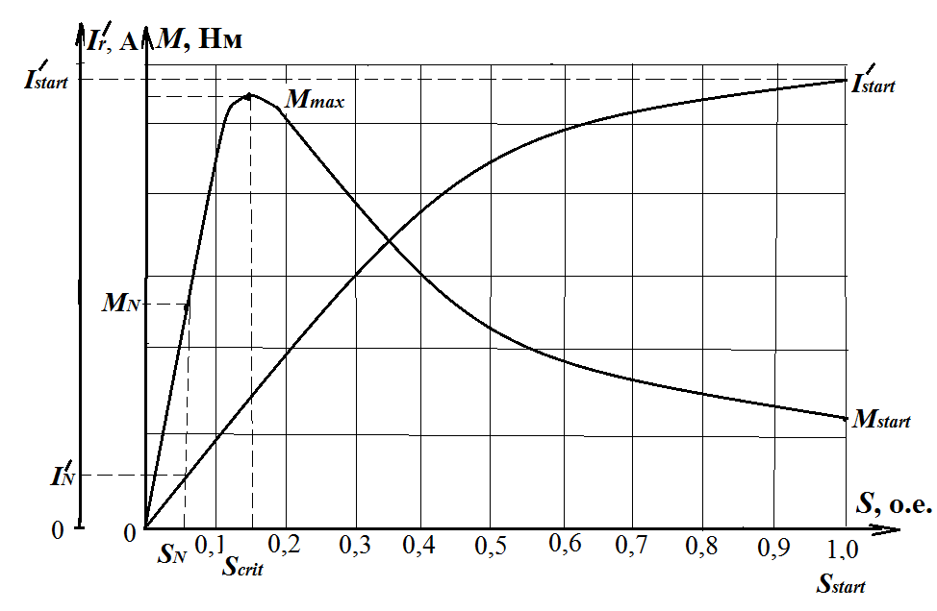

Fig. 3.3 – Asynchronous motor starting characteristics

We can see the disadvantages of direct start at the graph.

To improve the starting characteristics, it is necessary to increase the active resistance of the rotor winding, but only during the start period.

For this, the rotor grooves are made deep and narrow, and the skin-effect is used – it is the effect of displacement of the current to the surface of the rotor.

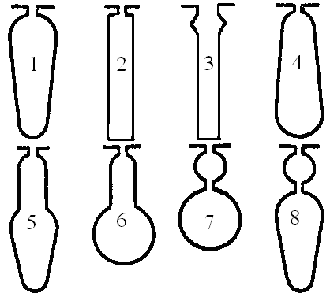 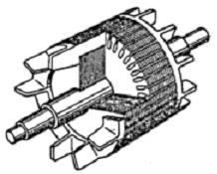

*a* *b*

Figure 3.4 – Shape of rotor slots and rotor with short-circuited winding

of asynchronous motor

1-4 – deep grooves; 5-6 – shaped grooves; 7–8 – double winding

The skin-effect increases the active resistance of the rotor winding by the start.

The phenomenon of the skin-effect is that the magnetic field of the stator current does not immediately penetrate the entire depth of the rotor grooves. But immediately induced EMF and current appears. In this case, the section of the conductor of the winding in which the current is induced is small, so the resistance is large. This improves the starting characteristics of the engine.

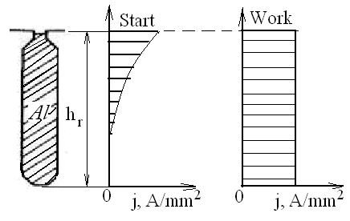

Figure 3.5 – Current density plot taking into account appearance of the skin effect

For large engines, the skin-effect is not enough. Therefore, the design of the rotor is changed. **In this case, make the phase rotor**.

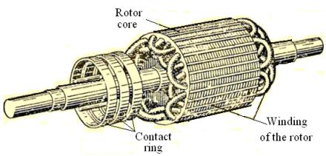 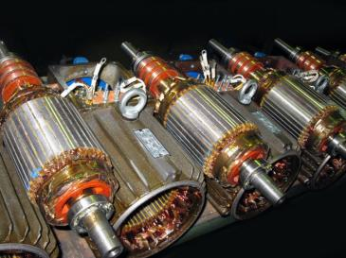

Figure 3.5 – Rotor with phase winding

Rotor core. Winding of the rotor. Contact ring

Consider as an example an option like in the homework. Suppose that the rheostat has **3 stages**. We shall construct the starting characteristics provided that the value of the starting current is not greater than the value of the two rated currents. Calculate the resistance of the starting resistors *RΣ*, in which the starting current is the rated current of the **two values**, А.

The phases of the winding are connected by a star and their ends are connected to three slip rings (3) mounted on the shaft (2) and electrically isolated both from the shaft and from each other.

With the help of brushes (4), which are in sliding contact with the rings (3), it is possible to turn on starting rheostats (5) in the phase winding circuits.

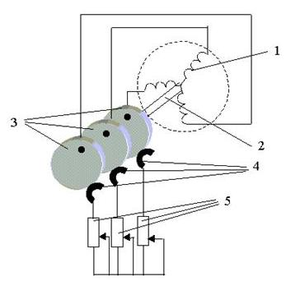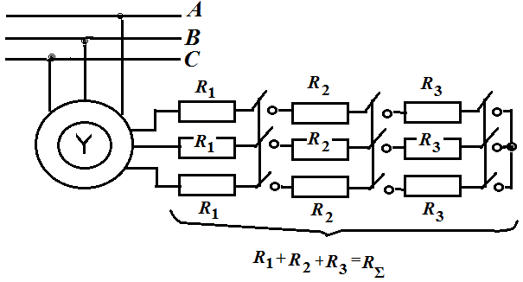

The starting rheostat is introduced into the rotor winding at the time of starting. And with an increase in the speed of rotation of the rotor, the rheostats are gradually removed.

Fig. 3.6 - Rheostat switching circuit: 1 – Stator winding;

2 – shaft; 3 – three slip rings;

4 – brushes;

5 – starting rheostats

**Induction (an asynchronous) motor start** *M, Ir/* = *f*(*s*)

The electromagnetic moment on the shaft an asynchronous motor is, N·m:

.

The reduced value rotor current of the asynchronous motor is, A,

.

If you enter the starting rheostats *R*Σ, the starting current will decrease and the starting torque will increase.





At start up *s*=1. Therefore:





Suppose that the rheostat has 3 stages. We shall construct the starting characteristics provided that the value of the starting current is not greater than the value of the two rated currents. Calculate the resistance of the starting resistors *RΣ*, in which the starting current is the rated current of the two values, А,

,

where *R*Σ, Ohm – the resistance value of the three stages starting rheostats.

The resulting value of the resistance is divided into three stages, Ohm,

**

Build four characteristics  in one graphic field: natural characteristic (without starting resistors) and three characteristics with one, two and three steps starting resistors. On the same graphic field build four characteristics : one – without rheostats and three characteristics with one, two and three rheostat steps on the same field, fig. 3.7.

The value of the electromagnetic moment on the shaft introduced *N* steps starting rheostats, (*N*= 1, 2, 3), N·m,

.

The critical slip *scr*, which corresponds to the maximum moment of the asynchronous motor can be calculated

**.

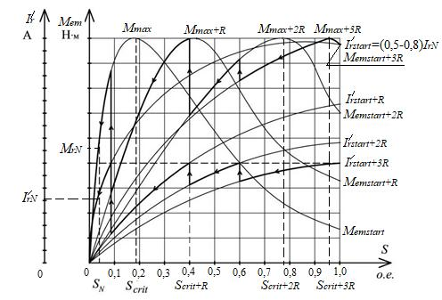

Fig. 3.7 – Starting characteristics of an asynchronous motor

with a phase rotor *I*/*r*, *Mem*(*s*)

The maximum electromagnetic moment of the asynchronous motor with the critical slip, N·m,

*.*

Calculate the asynchronous motor critical slips with *N* = 1, 2, 3 steps rheostat that are put into the rotor winding for better structuring characteristics

**; **; **.

With the introduction of starting rheostats, the maximum torque does not change. Only the critical slip changes (increases). If it is necessary to increase the starting torque, then similar calculations are carried out.

**Problems of starting single-phase asynchronous motors**

A circular magnetic field that rotates can be created by a **three-phase symmetrical** system of currents.

A **two-phase system** of currents can create a field that will rotate, but its shape will be elliptical.

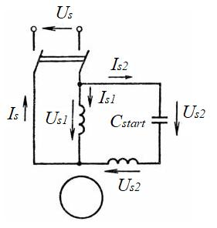 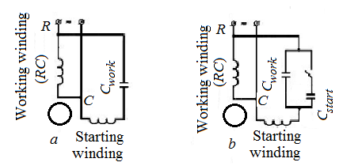

Fig. 3.8 – Connection schemes for single-phase asynchronous motors:

*a* – with a working capacity *Сwork*, *b* – with a working capacity *Сwork*

and starting capacity *Cstart*

**Single-phase currents** do not create rotating fields. They create a pulsating field. Therefore, asynchronous motors do not have a torque. Therefore, we are use a special method, that is creating an additional, second phase. Starting capacitors are most often used for this. In this case, an elliptical field appears that rotates and a torque is generated.

After starting the starting capacitors must be switched off, otherwise they will burn out. But the power of such an engine will be approximately three times less than with a three-phase current. Therefore, the working capacitors are usually installed additionally. They are switched on after receiving the nominal mode. This will allow to get 65–70 % of the power from the engine operation from the three-phase current.

We use a special method that creates a second phase. For this, starting capacitors are most often used. Working capacitors are used to increase power.

**Asynchronous generator**

For an asynchronous generator, you need to know how it will work:

1) On the energy system; or 2) to an autonomous power receiver.

When it works on the power system, the generator will take from the system the reactive power (current), which is necessary to create magnetic fields.

When an asynchronous generator operates on a stand-alone receiver it is necessary to use an additional source of reactive current. For example, it’s capacitors.

**Methods of regulating an asynchronous motor speed**

The speed of the induction motor can be adjusted in several ways:

1) **Changing the current (voltage)** **frequency *f*=*var****.* Now it became possible, because the transistors of the new series – IGBT transistors – were obtained.

Prior to this, DC motors were used for drives with speed control. These engines are expensive, difficult to build, repair and operate. But they were easy to adjust the speed of rotation. Now in the world there is a replacement of direct current motors for asynchronous motors with frequency change.

2) **Change by the number of pairs of poles.** It's an old way. To do this, it’s change the stator winding circuit. The speed can be adjusted, but the steps.

3) **Change by the** **changing the voltage**.

You can adjust in small limits and you can only reduce the speed by reducing the voltage. Moreover, at the same time the motor torque will decrease significantly, because the torque varies proportionally to the decrease in the voltage in the **second degree**.

4) **Change by the** **changing** **the slip** for asynchronous motors with a phase rotor. To do this, you can use the starting rheostats. The speed control is possible in a small range, and at the same time the coefficient of efficiency decreases.

**Reverse** is change of the direction of the motor rotation to the opposite. To change the direction of rotation of the asynchronous motor to the opposite (for reverse), you must swap any two phases.

**The losses and efficiency of an asynchronous motor.**

**The energy diagram of the asynchronous motor**

The conversion of energy in an asynchronous motor, as in other electric machines, is associated with energy losses. As we have said, these losses are divided into electrical, magnetic, mechanical and additional losses.

We construct an energy diagram of an asynchronous motor, where we show how the energy conversion takes place, fig. 3.9.

We take the active power *Pint* from the energy system.

Part of this power is expended to cover the electrical losses caused by the heating of the stator windings *РelS* = *mS*·*IS*2·*rS*, and another part – to cover the magnetic losses in the stator core *РmagS*.

Then the power is transmitted through the air gap to the rotor by means of a magnetic flux. Therefore, this power is called **electromagnetic power**

*Рelmag* = *Рint* – (*РmagS* + *РelS*).

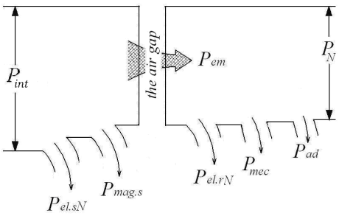

Figure 3.9 – The energy diagram of asynchronous motor

Part of the electromagnetic power is expended to cover The electrical losses in the rotor windings *Рelr* = *mr*·*Ir*2·*rr* = *m*s·*I*/*r*2·*r/r*.

Parameters with strokes show the changed values of the rotor parameters. We use such parameters to make calculations easier. Such a replacement allows the action between a stator and a rotor to be replaced by magnetic fields to study electrical circuits. It is easier. In doing so, we can explore the processes in the machine with simple laws, with the help of the laws of Kirchhoff and Ohm.

The next type of losses are the mechanical losses. There are the losses from friction in bearings and friction of the rotor about the air that arise when it rotates. Typically, the mechanical losses are assumed to be 2-2.5% of the rated motor power.

Magnetic losses in the rotor we neglect, because the frequency of magnetization reversal of the rotor in the nominal mode is very small

*frN* = *fsN*·*sN*.

*sN* = 2 ÷ 8 %, so *frN* = (0,02÷0,08)·50=1÷4 Hz.

Therefore, these losses are so small that they are usually neglected.

At the end of the calculations, additional losses are added *Рadd*. The additional losses are caused by the presence in the motor of the scattering fields and the pulsation of the field in the teeth of the rotor and stator.

Thus, the rated power of the induction motor is

*РrN* = *Рint* – ∑*Рi*,

where ∑*Рi* – sum of asynchronous motor losses, W:

∑*Рi* = *Рmags* + *РelsN* + *РelrN*+ *Рmec* + *Рadd*.

Efficiency of an asynchronous motor

η*N* = *РrN*/*Рint* = 1 – ∑*Рi*/*Рint*.

Depending on the power of the asynchronous motors, their efficiency at the rated load can be in the range from 83 to 95% (the upper limit corresponds to the high-power engines).

**Methods of regulating an asynchronous motor speed**

1) changing the frequency of the current (voltage) *f* = *var.*

2) Change in the number of pairs of poles.

3) Speed regulation due to voltage variation.

4) Speed control by changing the slip factor (for the phase structure rotor).

**Reverse of asynchronous motor**

To reverse an asynchronous motor, you need to swap any two phases. This will change the direction of rotation of the motor rotor.

**Asynchronous motor characteristics in operation**

By the performance characteristics of an asynchronous motor we mean:

*ns*, *M*, η, cosφ=*f*(*Pr*) at *Us*=const and *fs*=const

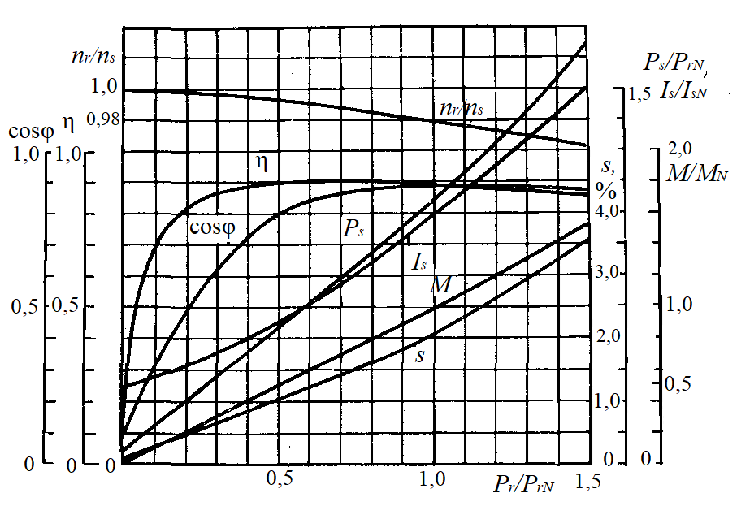

Fig. 3.10 – Performance characteristics of 50 kW, 220/380 V, 1470 rpm squirrel-cage

asynchronous motor, plotted in relative units

In addition, an important indicator is the overload capacity factor *kn,* and for squirrel-cage motors – also the multiplicity of starting current and starting torque.

**ASYNCHRONOUS GENERATOR**

The generator converts mechanical energy into electrical energy. The generator supplies active electricity to the electrical network. To work in generator mode, mechanical energy must be supply to the rotor. However, if you just rotate the rotor, it will not create electricity. The rotor design is just metal. This is a shaft; the rotor core is located on the shaft. Molten metal (aluminum or copper) poured into the grooves of the rotor core.

Therefore, it is necessary to supply reactive current (capacitive current) from a special AC source to the stator winding. This current will create a circular rotating magnetic field in the air gap.

You must remember that the coefficient called **slip** **in the generator mode is less than zero** (s<0)

The motor rotates the rotor of the asynchronous generator faster than the stator field rotates. An asynchronous generator needs reactive current, so asynchronous generators are not often used. The most famous use of asynchronous generators as wind generators of low power (up to 200-300 kW). In practice, asynchronous generators with closed-loop (squirrel-cage) and phase rotors are used.

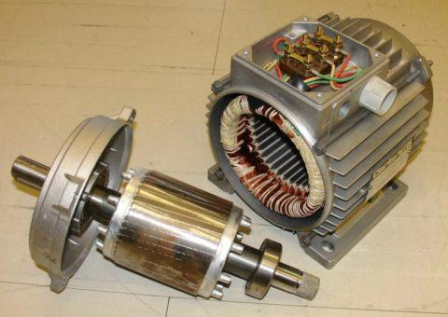 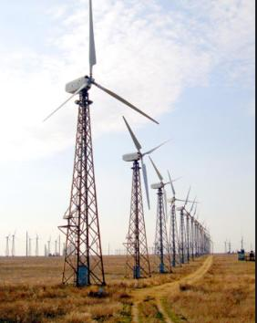

Fig. 3.11 – Asynchronous generators with closed-loop (squirrel-cage) rotors

Fig. 3.12 – Wind power station

The field will create an EMF in the rotor winding according to the law of electromagnetic induction. Rings on both sides close the winding. Therefore, a current appears in the rotor winding. Current creates a rotor field. When an external motor rotates the rotor asynchronous generator, the rotor field in the conductors of the stator winding creates an active current, active power.

Asynchronous generator **consumes** reactive current and **gives** active current to the network. Those a capacitive current flows from the mains or from the capacitor bank to the stator winding to create a magnetic field in the air gap and induce EMF and currents in the rotor winding.

In addition, the magnetic field of the rotor in the stator winding creates an active current, active power for electrical receivers.

**Conclusion:** For an asynchronous machine to operate in generator mode, a reactive power source is required that generates a rotor magnetic field.

A scale of possible slip values was at fig. 3.2.

The disadvantage of asynchronous generators is the large reactive power that they consume from the network. The value of this power is proportional to the magnetizing current *IS*0 and can be 25-45% of the machine rated power.

Therefore, for the operation of 3-4 asynchronous generators, it is necessary to take the same power from the network as the power of one asynchronous generator.

If the generator does not work with the network, and works separately, then you need to install a synchronous generator of the same power as the power of one asynchronous generator or a set of high-capacity capacitor banks.

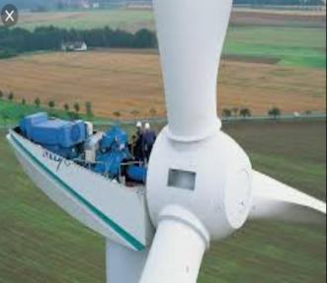 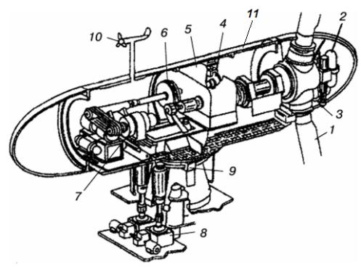

Fig. 3.13 – Modern wind turbine with a horizontal axis of rotation

1 – impeller (blades); 2 – blade rotation system; 3 – sleeve; 4 – brake; 5 – multiplier;

6 – fluid coupling; 7 – generator; 8 – the rotation system mechanism;

9 — brake of the rotation system; 10 – sensors; 11 – gondola

**Questions to the Part 3**

**Asynchronous machines**

1. In what modes can asynchronous machines work? Indicate the areas of asynchronous machines use in these modes.

2. What are the design rotors of asynchronous machines?

3. Describe the design of the short-circuited rotors of asynchronous machines. What is the shape of the grooves in the short-circuited rotor of an asynchronous machine?

4. What metals used for the windings short-circuited rotors of asynchronous machines?

5. Describe how an asynchronous machine works in motor mode.

6. How an asynchronous machine works in generator mode, when it turned on for an autonomous load?

7. How an asynchronous machine works in generator mode, when it turned on an electrical network?

8. What problems has the induction motor when starting up?

9. How can you improve the startup characteristic of an asynchronous motor with short-circuited rotor?

10. How can you improve the startup characteristic of an asynchronous motor with phase rotor?

11. What is slip in asynchronous machines? What is the slip of an induction motor when it starts?

12. To what limits does sliding in asynchronous machines change under different operating modes? What is the slip of an asynchronous motor when it starts?

13. What is the slip of an asynchronous motor when it starts?

14. To what limits does sliding in asynchronous machines change under different operating modes? How to switch to generator mode from engine mode?

15. How to switch to in braking mode from engine mode?

16. What is reverse of electrical machines? How to change the direction of an asynchronous motor rotation (reverse)?

17. How to make the starting current of an asynchronous motor not more than two rated values of the stator current?

18. What problems arise when an asynchronous motor starting from a single-phase electrical network?

19. What are the ways of regulation an asynchronous motor speed?

20. What are the losses and efficiency of an asynchronous motor? Build and explain an asynchronous motor energy diagram.

**Part 4**

**Synchronous Machines**

Synchronous machines (SMs) are used in different modes: generators and motors (and as synchronous compensator).

Synchronous generators (SGs) are the largest machines. Their power reaches 1200 MW. In the world, scientists are working to further increase the power of synchronous turbogenerators, which are installed at nuclear power plants. SGs are the main sources of electrical energy on Earth.

Generators that work on thermal and nuclear power plants are called turbogenerators. Thermal and gas turbines rotate the rotors of turbogenerators at a speed of 1500 and 3000 rpm.

Generators that work at hydraulic stations are called hydro generators. Hydraulic turbines rotate the rotors of the generators at a low speed.

Depending on the speed of rotation, the design of the generators rotors changes:

1) In turbogenerators the rotors are made with implicitly expressed poles in order to ensure their mechanical reliability. The rotor is made of a monolithic turbine steel. On the surface of the rotor core, grooves are made into which the winding of the rotor is laid. This winding is called the "field winding". A constant current flows through this winding. Current creates the main working flux of the generator.

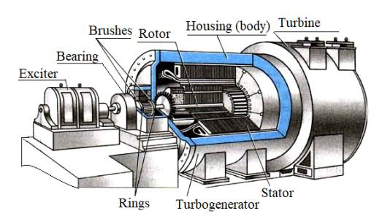

Fig. 4.1 – Turbogenerator

2) The poles of the rotors of the hydro generators are made explicit. They are mounted on the rim with the help of special structural elements in the form of a hammer or "swallowtail". Sometimes the poles of small generators are bolted.

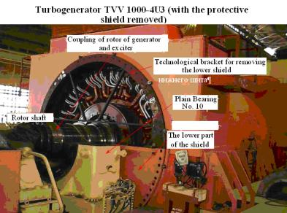

**Rotor of TVV 1000-4U3**

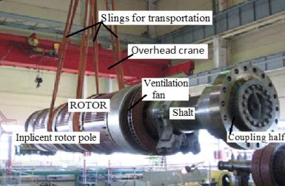

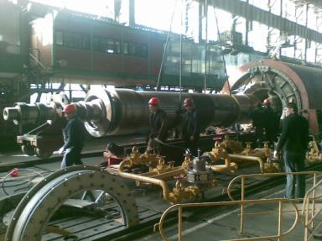 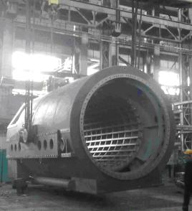

|  |  |
| --- | --- |
| The process of removing the rotor from the stator of a turbogenerator | Housing (body)of turbogenerator |
|  |  |
| Blanks for stator winding rods  Заготовки для стержней обмотки статора | Stator core of synchronous machine without winding |

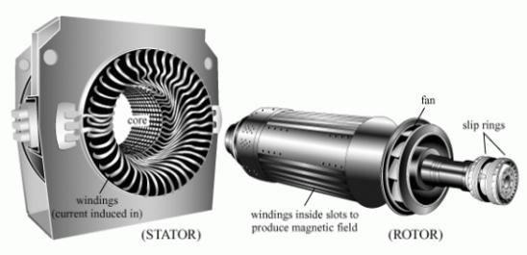

Fig. 4.2 – Turbogenerator

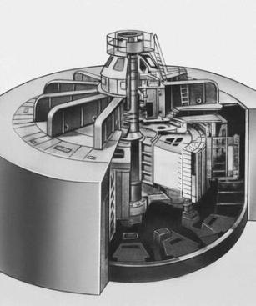 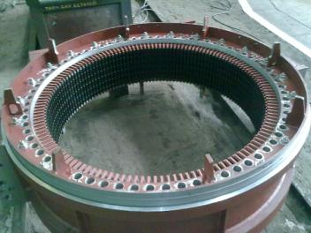

Hydrogenerator Stator core

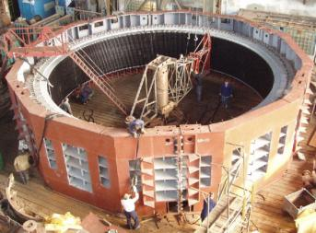 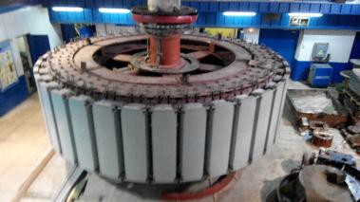

Hydrogenerator stator during assembly Explicit rotor of hydro-generator

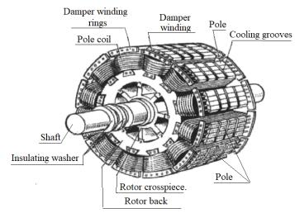 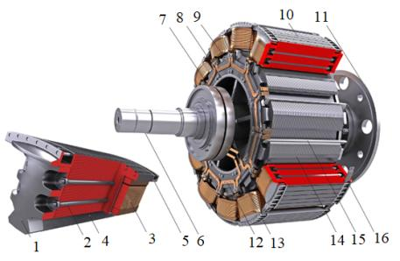

Fig. 4.3 – Implicit rotor of synchronous machine

1 – Pole core; 2 – Tie rods; 3 – Rotor winding; 4 – "Dovetail" pole; 5 – Starting (damper) winding; 6 – Shaft; 7 – Rotor rings; 8 – Rotor skeleton; 9 – Pole;

10 – Damper winding rods; 11 – Half coupling; 12 – Field winding connections;

13 – Pole attachment point; 14 – Pole mounting groove; 15 – Wedge;

16 – Rings that close the damper unwinding

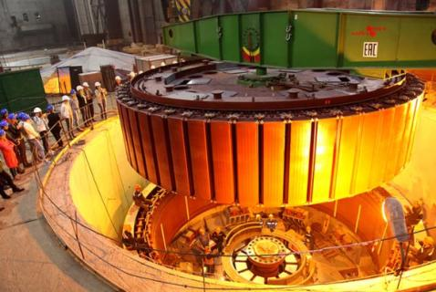

Fig. 4.4 – Hydrogen generator assembly

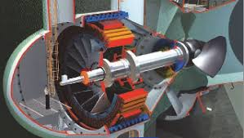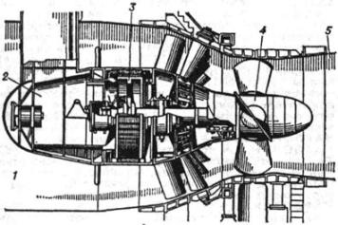

Fig. 4.5 – Capsule hydro-generator

**The pathogen of turbogenerator**

For powerful turbogenerators (500-1200 MW), rings and brushes are not used to supply direct current to the excitation winding (rotor). Additional equipment is used for them: an exciter and a rotating rectifier. Direct current after the rectifier goes along copper busbars to the excitation winding of the turbine generator through the central hole in the shaft.

Inverted synchronous generator has increased number of poles. For example, if the turbogenerator has 4 poles (p=2), that the pathogen has 12 poles (p=6). Therefore, the frequency of the alternating current that goes to the rectifier is 150 Hz. AC current is better rectified if its frequency is higher.

The layout of equipment in the NPP turbine hall is shown in the fig. 4.3. As an example, the data for the TVV-1000-2U3 turbine generator are presented.

The **pathogen** consists of a stator and a rotor like a turbogenerator. But the pathogen has an inverted design. The field poles are located on the stator. The three-phase winding is laid in the rotor grooves.

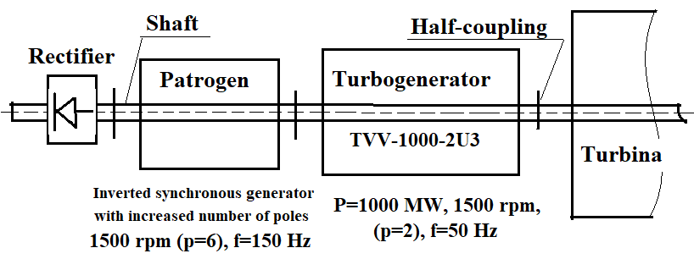

Fig.4.6 – The layout of equipment in the NPP turbine hall

The figure shows the upper half of the pathogen. Poles are placed on the stator, into the winding of which direct current is supplied. The poles consist of a core and a winding. On the rotor of the pathogen is a three-phase winding in which a three-phase alternating current is induced.

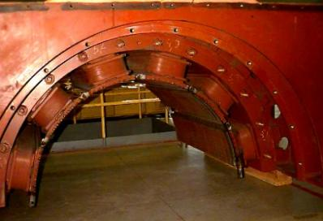 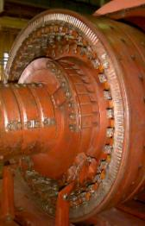

The upper half of the pathogen

Rotating rectifier

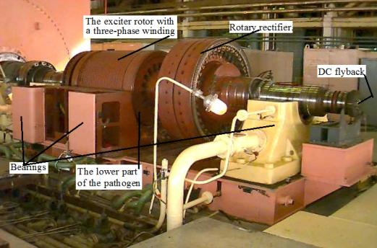 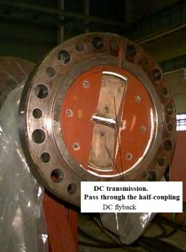

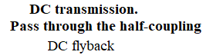

Fig.4.7 – Open exciter (without the upper housing portion) and rotating rectifier

After the pathogen, a rectifier is placed on the shaft (figure). After the rectifier, direct current returns to the rotor winding turbogenerator through the center of the shaft. With such a system, there are no rings on the rotor.

**Hydro generators**

Hydroelectric power plants are equipped with hydro generators. These machines always have an explicit pole rotor design. Synchronous motors and synchronous compensators also have this design. Usually the number of poles in synchronous machines with explicit pole rotor are more **6**.

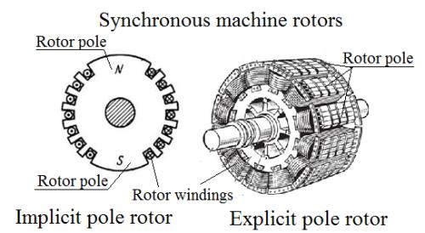

Fig. 4.8 – Rotors of synchronous machine

**All hydro-generators make explicit poles rotor.**

The ***hydro* turbine** rotates slowly. Therefore, in order for the hydro generator to produce electrical energy with a frequency of 50 Hz, the number of poles must be large:

, tur/min

If nr should be small, then the number of pole pairs should be large. Therefore, the rotor has many poles and all hydro-generators make explicit poles rotor*.*

|  |  |
| --- | --- |
|  | **Cross section of the explicit poles rotor**  1 – pole; 2 – counter wedges for fastening the pole (fasteners); 3 – insulating washer; 4 – cored pole insulation; 5 – insinuated conductor of excitation winding; 6 – the insulation of conductors; 7 –the damper core; 8 – segment of the damper winding; 9 – connection between segments; 10 – the tie rod стяжная шпилька; 11 – tail of the T-shape; 12 – steel washer стальная шайба; 13 – an inter-pole brace; 14 – spring |

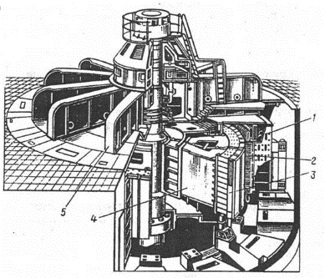 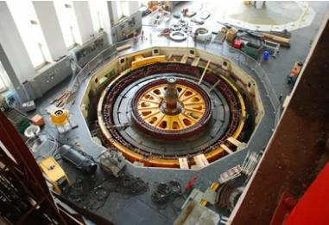

Fig. 4.9 – Hydro generator 225 MW, 15.8 kV, 125 rpm:

1 – stator housing; 2 – stator core; 3 – pole of the rotor; 4 – the rim of the rotor;

5 – load-bearing cross

**General view of a hydroelectric power station**

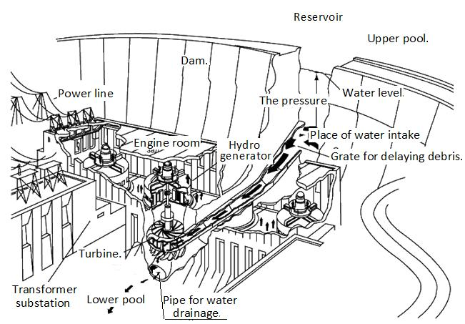

Fig. 4.10 – General view of a hydroelectric power station

Reservoir. Water level. Upper pool. The pressure. Place of water intake. Power line. Engine room. Dam. Grate for delaying debris. Turbine. Pipe for water drainage. Transformer substation. Lower pool.

**Principle of operation of a synchronous generator**

The direct current goes along the rotor winding and creates a constant magnetic field of the machine. The turbine rotates the rotor of the generator. The constant field of rotor for the stator winding is variable due to rotation. The rotor field in the stator winding induces EMF according to the law of electromagnetic induction.

Stator currents create a circular magnetic field that rotates at a speed

, rpm.

The rotor and stator field rotate at the same speed *nr* = *ns*. Therefore, the machine is called **synchronous**.

Like an asynchronous machine, the stator consists of a body and a core. The stator core of the synchronous machine is made of thin plates of electrotechnical steel. The thickness of the plates is 0.5 or 0.35 mm.

A three-phase symmetrical winding lays in the stator grooves. The alternating current passes through the winding.

Rotors come in two designs: with explicit poles and with explicit poles and with implicit poles. But in any case, a constant current is in the rotor winding.

All turbogenerators have a design with implicit poles. These are the biggest cars. Turbogenerators have two or four poles. Therefore, the stator field and the rotor rotate at a speed of 3000 or 1500 rpm, if the voltage frequency is 50 Hz.

Hydro generators have a lot more poles. Sometimes the number of poles is 60-100 or more. For all synchronous generators, the stator winding has two layers.

**Cooling systems of turbogenerators**

There are several types of cooling synchronous machines. Usually hydrogen generators are cooled by air. Turbogenerators use cooling by air, hydrogen, hydrogen and water. The turbogenerator stator winding can cooled with water. Water flows in special channels in the grooves of the stator.

An increase the power of turbogenerator is possible with improved cooling.

**Basic cooling systems:** Air, hydrogen, hydrogen + water in the stator winding bars

**Cooling system selection criteria are:**

**It is known that hydrogen is more efficient than air, and water is more efficient than hydrogen:**

1) Air cooled generators are simpler, but limited in power output.

2) Hydrogen and water-cooled generators are smaller and more efficient, but more complex and require special systems.

In turbogenerators of high power, only hydrogen-water cooling is used.

However, at present, special attention paid to air-cooling.

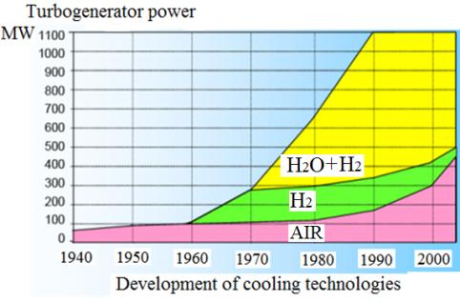

Fig. 4.11 – Zones of changing cooling systems depending on power

**Anchor reaction of synchronous machines.**

**The method of two reactions that Blondel created**

The stator current creates a magnetic flux called the “anchor reaction flux”. Must remember that in synchronous machines the stator is called the " **anchor**".

The current of the winding stator creates a magnetic field. The direction of this field depends on what kind of load the nature of the generator works: **inductive load, capacitive load or active load**.

The Descartes coordinate system for synchronous machines is inconvenient. Therefore, Blondel suggested using a different coordinate system. He proposed using the two axes *d* and *q*. Between these axes there are always 90 electrical degrees. Therefore, all processes in the machine can be shown only for two poles, fig. 4.12.

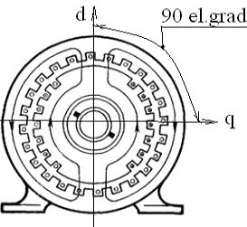 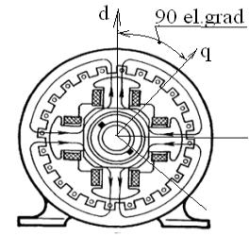

The number of pole pairs is:

p=1 p=2

Fig. 4.12 – Anchor reaction (a magnetic field action from stator current) in SM

So it's easier to understand: The axis *d* is directed along the axis of the rotor poles; this is the longitudinal axis. And the *q*-axis is perpendicular to the axis of the rotor, this is the transverse axis.

If the load is **active**, then the **flux of the anchor reaction** is directed perpendicular to the flow of the field coil (rotor flow). The flow is called **transverse and** the flux practically no effect on rotor flux.

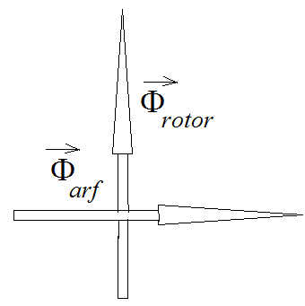 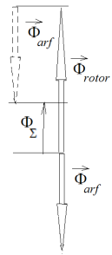 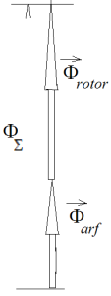

***R L C***

If the load is **inductive**, then the **anchor reaction flux** directed along the axis of the field winding flux, but in the other direction. The flux called **longitudinal and demagnetizing.** It reduces the main flux of the machine. ФΣ – is the flux that staded.

If the load is **capacitive**, the anchor reaction flux is directed in the same direction as the flux of the rotor, and increases it. This flux is called longitudinal, which magnetizes, increases the total flux of the machine.

If the load is **active**, the anchor reaction flux is directed perpendicular to the flux of the rotor flux and has practically no effect on it.

Usually the generator **load is mixed**. Then the anchor reaction flux is directed at an angle to the rotor flux. The angle depends on the ratio of active and reactive loads.

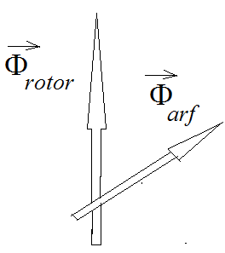 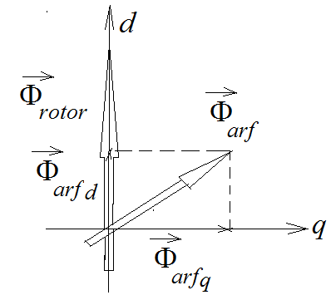

Fig. 4.13 – Directed of flux of anchor reaction

Scientist Blondel proposed **to lay out** all parameters in synchronic machines on two axes *d* and *q*.

**Characteristics of synchronous generator (SG)**

1. Generator characteristics when operating in different modes

1.1**. Idling characteristic** *Es*0=*f*(*ir*) at *nr*=const and *Is* = 0, fig. 4.14.

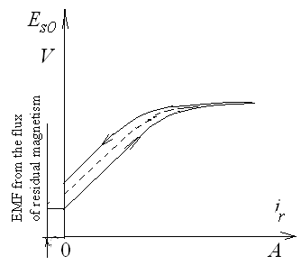

*EMF from the flux of residual magnetism*

The area of the magnetization loop is proportional to the magnetic losses (losses in steel). With increasing magnetizing current, the EMF first increases proportionally, but then the dependence becomes nonlinear. The shape is influenced by the saturation effect of the steel. At a certain value of the excitation current, the EMF stops changing with an increase in the excitation current.

Fig. 4.14 – Idling characteristic of

synchronous generator

Full saturation sets in. The additional flow can no longer pass into the steel.

If you reduce the excitation current, then the EMF graph will go higher. This happens because the flux of residual magnetism is added to the flux from the rotor current.

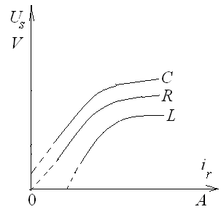

1.2 **Load characteristic** *Us*=*f*(*iif*)

at *nr*=const and *Is* = *IsN*, fig. 4.15.

We cannot build this characteristic from the excitation current equal to zero, because without the presence of a certain value of the rotor flux, we cannot provide the nominal value of the stator current.

Why do you think we have built three characteristics? Explain why with the same field current (rotor flux) the stator voltage will be different. (For this, the direction of the armature reaction flow must be considered).

Fig. 4.15 – Load characteristic of synchronous generator with different types of load

1.3 **External Characteristics** *Us*=*f*(*Is*) at *nr*=const and *ir* = *irN*= const, fig. 4.16.

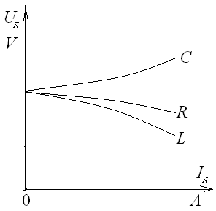

If the load is capacitive, then as the load increases, the total flux increases, and the generator voltage increases too.

The requirement *ir* = *irN* = const does not allow to regulate the total flux.

If the load is inductive, then the voltage decreases due to the action of the flux reaction of anchor, which reduces the total field of the generator.

Fig. 4.16 – External

characteristic of SG

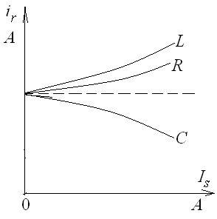If the load is active, then the voltage decreases according to Ohm's law

**1.4 Adjustment characteristic (artificial characteristic)** *iif* =*f*(*Is*) at *nr*=const and *Us*= *UsN* = const, fig. 4.17.

If the load is **capacitive**, the rotor current must be reduced so that the voltage does not change. This is due to the fact that the reaction flux of the anchor enhances the total field of the machine.

Fig. 4.17 – Adjustmentcharacteristic of SG

If the load is inductive, the rotor current must be increased so that the voltage does not change. This is due to the fact that the reaction flux of the anchor reduces the total field of the machine.

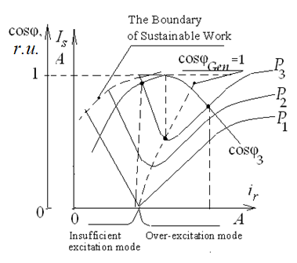

2. ***U -* like characteristics***Is* =*f*(*iif*) at *nr*=const and *Рs*= *Рsi* = const, fig. 4.18.

These characteristics are constructed for different values of the generator active power.

When the generator is operating in an insufficient excitation mode, it gives active energy to the electrical network, and takes the reactive energy from the Power Grid. When the generator is operating in over-excitation mode, it gives active energy to the electrical network, and at the same time gives reactive energy into the Power Grid.

Fig. 4.18 – U - like characteristics

of synchronous generator

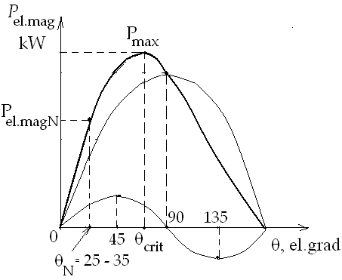**3. Angle characteristic of the generator** *Pelmag* = *f*(θ)

The angle θ is the angle between the direction of the rotor flux and the direction of the reaction flux of the anchor. We can say that this is the angle between the EMF vector of the generator in idling mode and the generator voltage vector in the operating mode.

This angle θ is called the "**load angle**".

Dependence of electromagnetic power *Pelmag* on load angle:

Fig. 4.19 – The angular characteristic of a hydro generator



where *m* – number of phases (*m* =3); *Es0* – EMF generator in idling mode;

*UsN* – generator rated voltage; *xd* – inductive reactance of anchor reaction flux along axis *d*; *xq* – inductive reactance of anchor reaction flux along axis *q*.

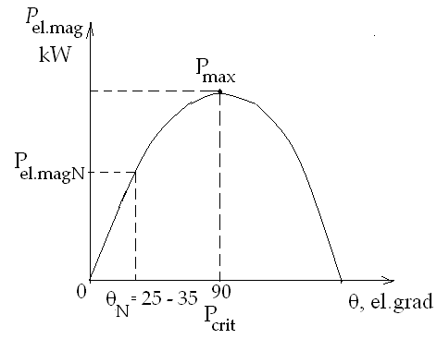For hydro generators *xd* > *xq*. This is because the gap in the axis *d* is small, and along the axis *q*, the gap is large.

We will construct the angular characteristic for the hydro-generator, fig. 4.19.

For turbogenerators *xd* = *xq*. Therefore, the electromagnetic power will be

.

Fig. 4.20 – The angular characteristic

of a turbogenerator

Let's build the angular characteristic of a turbogenerator, fig. 4.20.

The overload capacity of the generator is the ratio *Pmax* to *Pel.magN.*

.

The overload capacity of the generator is the ratio



The overload capacity of turbogenerators is usually *koverl* = 1,7-1,8

The overload capacity of hydro generators is usually *koverl* = 1,3-1,4.

Synchronous generator can be loaded slowly or quickly.

With a slow increase in load, **static stability** is established, with a fast set **dynamic stability**. **Static stability** characterizes the ability of the generator to work stably with a slowly changing load.

**Dynamic stability** characterizes the generator's ability to work stably under rapidly changing loads.

**Rotor swing**

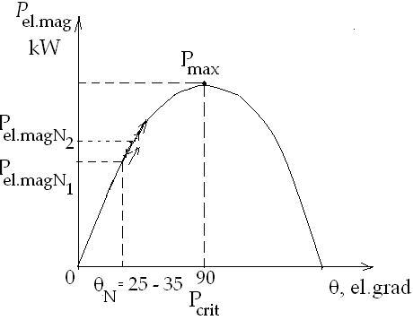If the load angle increases due to a change in the magnitude and nature of the load, the power value is not set to the desired value. And there is an increase, then a decrease. The rotor swings relative to the desired value, fig. 4.21.

If you do not reduce these swings, then the synchronous mode will break. The connection between the rotor and the stator field can break. The rotational speed of the rotor and turbine will begin to increase. They can collapse. This is an accident.

Fig. 4.21 – The rocking of the synchronous generator

It is necessary to take measures to calm the fluctuations. To do this, generators make a damper winding. This winding is placed in the slots, which are made in the tips of the poles of the rotor.

The damper winding in turbogenerators is placed at the bottom of the rotor slots.

**Parallel operation of synchronous generators**

In power stations and industrial plants, several generators often work in parallel, on the same Power Grid.

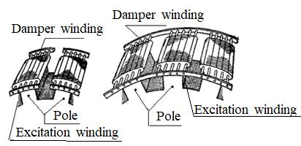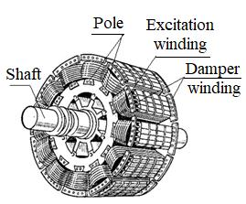

Fig. 4.22 – Design of damper windings of synchronous machine rotors

**The following conditions must be fulfilled**:

1) The EMF of the generator stator winding must be equal to the mains voltage

*Es*0 = *Uel.n*

2) The frequency of the generator voltage must be equal to the frequency of the mains voltage *fs* = *fel.n*

3) The order of alternation of the generator phases should be the same as the order of the electrical network phases (*ABC*)*gen* = (*ABC*)*el.n*

4) When the generator is turned on, its voltage should be in the same phase as the mains voltage.

Synchronoscopes are used simultaneously to determine the fulfillment of all conditions Now arrow synchroscopes are using. All conditions are met when the arrow enters the central sector.

Earlier synchroscope was made of **lamps** (fig. 4.23). Now use the **arrow synchroscope** (fig. 4.24). All conditions are met when the arrow enters the sector.

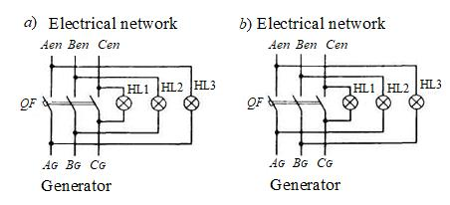

Fig. 4.23 – Scheme for switching on a lamp synchroscopes

*a*) according to the "extinguishing fire" scheme. The generator circuit breaker *QF*

is turned on when the lamps go out; *b*) according to the "rotation of the fire".

The generator circuit breaker is turned on when the lamps switch (on and off) rhythmically

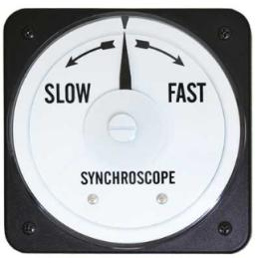 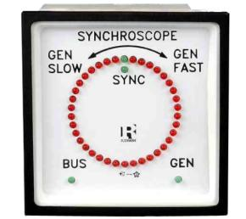

Fig. 4.24 – The arrow synchroscopes

**SYNCHRONOUS MOTOR**

All synchronous motors have a design with explicit poles. Number of poles *р*≥6.

A three-phase symmetrical alternating current is applied to the stator winding. Current creates a circular magnetic field that rotates in the air gap. The rotor field is stationary. It does not have time to form with the stator field, which rotates quickly.

**Therefore, synchronous motors do not have a direct start.**

There are different ways to start synchronous motors:

1) **Starting from an additional motor**. Usually used for this purpose asynchronous motor, fig. 4.25.

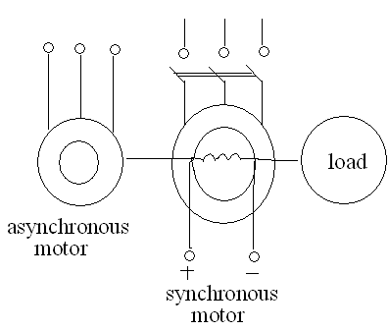The asynchronous motor spins the synchronous motor rotor to a speed that is almost equal to the synchronous speed (slip s = 5%). After that, the winding of the stator of the synchronous motor into the electric network is included. In the air gap, the current of the stator winding creates a circular magnetic field that rotates. The rotor catches up with the stator field. The stator field and the rotor field are added together and rotate together.

Fig. 4.25 – Starting from an additional

motor

2) **Frequency start**. The stator current frequency is reduced. The speed of rotation of the stator field decreases, and it has time to form with the rotor field. A torque is created that rotates the rotor.

3) **asynchronous start of a synchronous motor**. For this purpose, an additional winding is placed in the rotor poles. This winding is called starting. It has the form of a short-circuited winding of the rotor of an asynchronous motor.

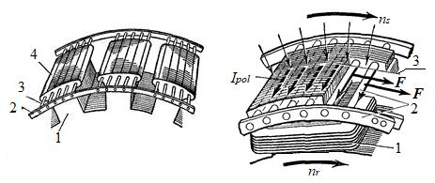

Fig. 4.26 – Placing a starting winding in a synchronous motor

when using asynchronous starting

1 – rotor pole; 2 – short-circuiting rings; 3 – «squirrel cage» rods; 4 – pole piece

The motor is connected to the network. But there is no current in the rotor winding. In the starting winding of the rotor, an EMF is induced, the rotor starts to rotate.

When the three-phase armature winding is switched on into the network, a rotating magnetic field is formed, which interacts with the current *Istart* in the starting winding (Fig. 4.26), creates electromagnetic forces *F* and carries the rotor along. After the rotor accelerates to a speed close to synchronous speed, the direct current that passes in the excitation winding creates a synchronizing torque that pulls the rotor into synchronism.

When sliding s = 5%, a constant current flows into the rotor winding. The rotor follows the stator field and rotates with it synchronously. At the same time, there is no current in the starting winding, because the stator field for the rotor has become constant.

But if the rotor starts to swing, the field becomes variable. In the starting winding of the rotor, an EMF is induced, a current appears. The magnetic field of this current calm the swings of the rotor.

Therefore, the starting winding is also called **damper winding**.

This method of launching is used most often.

**To reverse the synchronous motor**, you need to swap any two phases of the stator winding.

**Synchronous compensator**

A synchronous compensator is a synchronous motor that operates only in idling mode. Even he does not have a working end of the shaft. The synchronous compensator is designed to regulate the reactive power that it gives or takes from the electrical network.

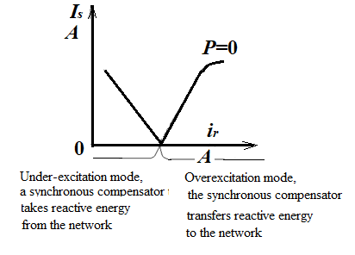This is done to improve the cosφ of electrical network and to provide asynchronous motors with reactive current.

The operating mode of the synchronous compensator is changed by changing the rotor current. A synchronous compensator is an expensive machine. Therefore, they are made only for 6 kV.

Fig. 4.27 – *U*-like characteristic of

synchronous compensator

You must remember that an electric machine can be only a generator or engine (motor). A synchronous compensator is a synchronous motor that operates only in idling mode. A synchronous compensator is an expensive machine. Therefore, they are made only for 6 kV.

You must remember that an electric machine can be only a generator or engine. A synchronous compensator is a synchronous engine that operates only in idling mode.

**Methods of regulating a synchronous motor speed**

The frequency of rotation of a synchronous motor *nr* is equal to the frequency of the rotating magnetic field *ns*, therefore, it can be regulated by changing the frequency of the supply voltage or changing the number of poles 2*p*.

The frequency of rotation by changing the number of poles in a synchronous motor is not used, because, unlike an asynchronous motor, it is necessary to change the number of poles on both the stator and the rotor. This leads to a significant complication in the design of the rotor. Therefore, in practice, a change in the voltage frequency is always used.

Frequency regulation of the speed of rotation of synchronous motors is used for small powers, when the load moments are small, and the inertia of the drive mechanism is small. At high powers, regulation is used only in some types of electric drives, for example, in electric drives of compressors and mills.

For synchronous motors of electric drives with a large moment of inertia, it is necessary to very smoothly change the frequency of the supply voltage so that the motor does not fall out of synchronism. It is especially difficult to start up the motor when the initial frequency must be fractions of a Hertz.

For such electric drives, the most suitable method is frequency control with self-synchronization, in which the motor, in principle, cannot fall out of synchronism.

The latter is achieved by the fact that the frequency converter is controlled from a system of rotor position sensors, as a result of which voltage is applied to each phase of the motor at load angles θ less than 90 °. With this regulation, conditions for stable operation of the motor are automatically ensured, and its overload capacity is determined only by the overload capacity of the frequency converter.

In a certain range, you can **adjust the speed by changing the stator voltage**.

The synchronous motor speed can be adjusted within small limits, and you can only reduce the speed by reducing the voltage. But you must remember that the motor torque will decrease because it changes in proportion to the voltage decrease.

**To reverse the all AC machines**, you need to swap any two phases of stator winding.

**The overload capacity of AC motors is low.**

Engine overload is the ratio of maximum torque to rated.

Asynchronous motors have overload capacity 2-2,3, and synchronous motors have overload capacity 3-3,5.

**Questions to the Part 4**

**SYNCHRONOUS MACHINES**

1. In what modes can synchronous machines work? Indicate the areas of synchronous machines use in these modes.

2. What are the design rotors of synchronous machines?

3. Describe the design of the explicit pole rotor of synchronous machine.

4. Describe the design of the implicit pole rotor of synchronous machine.

5. Describe how a synchronous machine works in motor mode.

6. What machines use an implicit pole rotor? Describe its design.

7. What power plants use synchronous turbogenerators? Describe the design of the turbogenerator rotor.

8. What is the main difference between rotors of asynchronous and synchronous machines? Why can't asynchronous machines work in synchronous mode?

9. What are the ways of excitation (supplying direct current to the rotor winding) of synchronous machines?

10. Describe the design of the pathogen in the system of synchronous machine/

11. What power plants use synchronous hydro generators? Describe the design of the hydro generator rotor.

12. Describe the principle of a synchronous generator operation.

13. Describe the cooling systems of turbogenerators.

14. What materials used to cool turbogenerators? Compare their characteristics.

15. What is the anchor reaction in synchronous generators? What determines the direction of the flux of the reaction anchor created by the stator current?

16. Describe the method of two Blondal's reactions. For which machines do you use this method?

17. How is the flux of anchor reaction in a synchronous generator with active, inductive and capacitive loads?

18. Build the angular characteristic of a synchronous generator.

19. Build and analyze the U-shaped characteristics of a synchronous generator.

20. How to reduce the rocking of the synchronous generator rotor?

21. What are the conditions for parallel operation of synchronous generators?

22. What problems do synchronous motors have when starting up? What are the ways to start synchronous motors?

23. Describe the design and purpose of the synchronous compensator.

24. What are the ways to control the speed of a synchronous motor?

**Part 5.**

**Direct Current (DC) machines**

**5.1 Construction of DC machine**

At first, we must repeat:

**An electric machine** is an electromechanical **device for converting** mechanical energy into an electrical (it’s generator) or electric energy into a mechanical (it’s motor).

More often DC machines use in motor mode. Generators usually use to charge batteries. DC generators produce the direct current itself, which has no ripple. Therefore, we will consider the advantages of DC machines **in motor mode.**

The DC motors use for the enterprises of ferrous and non-ferrous metal industry, for electric power station, mines, for machine-building plants and other.

They may be use for electric drives of mine hoists, for the main drives and for completing electrical drives of rolling mills and other machinery.

**Advantages of DC electric motor are:**

1. **High efficiency value** (Высокая эффективность), which is equal to 70 - 80% and increases with power growth. In some high-power DC motors, the efficiency may be reach 98 %.

2. **Good adjusting ability**. Engine speed easily adjusted within wide limits. Control systems for this are simple.

3. **High overload capacity** – DC motors can work for a long time (for tens minutes and even during hours) with a load that is higher than the rated power 15-17 times.

We must know the flaws of DC motors, that DC machines are complex, expensive and need constant service. Therefore, at present time, DC motors replace with asynchronous motors in enterprises and in the electro transport: in the tram, in the trolleybus, in the metro, in the electric locomotives and in the electric trains.

Currently, DC motors use only if there are **large overloads**.

For all types of electrical machines, the most important characteristic is the stability of insulation to heat, that is, the ability of insulation to maintain its insulating properties for a long time as the temperature increases.

By this property, insulation materials divide into classes (Tab. 5.1).

Table 5.1 – The classes of insulation materials

|  |  |  |  |  |  |  |  |  |
| --- | --- | --- | --- | --- | --- | --- | --- | --- |
| Insulation class for temperature  resistance | *А* | *Е* | *В* | *F* | *H* | *С* | 200 | 300 |
| Maximum temperature, ºС | 105 | 120 | 130 | 155 | 180 | >180 | 200 | 300 |
| Temperature rise , ºС | 65 | 80 | 90 | 115 | 140 | >140 | 160 | 260 |

Temperature rise is the maximum temperature minus 40 degrees by Celsius.

**The DC machines have two main parts, namely**:

Stationary part – stator; rotating part – an anchor.

**Also included in the design of the machine**:

Two bearing shields on which the anchor shaft rests; brush device.

Now let’s do a detailed discussion about all the essential parts of DC machine

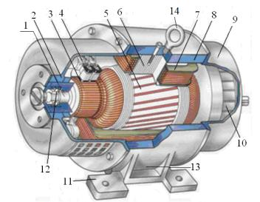 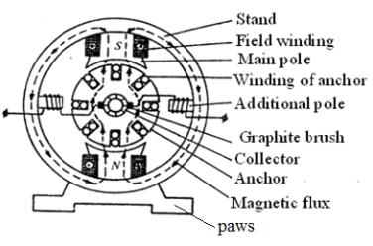

Fig. 5.1 - Construction of DC machine

1 – anchor shaft; 2 – front bearing shield; 3 – collector; 4 – brushes; 5 – anchor;

6 – the main pole; 7 – field winding (main poles winding); 8 – bed (of stand);

9 – back bearing shield; 10 – fan; 11 – paws; 12 – bearings; 13 – terminal box;

14 – eyebolt

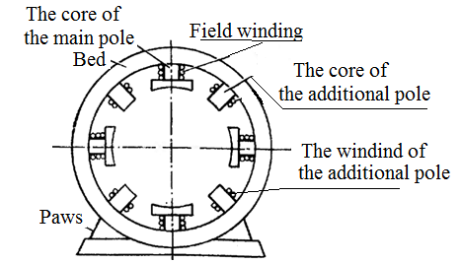1) **The STATOR is a stationary part**. It consists of a frame (yoke), the main and additional poles. The terminal box is on the bed. The ends of the field windings led out into the terminal box. Also on the stator, there are paws and devices for transportation (eyebolt, transport lugs).

**Construction of DC motor frame**

The frame (or the bed) of DC machine made up of cast iron or steel and forms an integral part of the stator (the static part of the machine).

It protects the machine, the main and additional poles are attached to the frame, and the support flaps are attached to the frame too. The main magnetic flux of the machine goes along the frame.

**Construction of main poles of DC machine**

The main poles attached to the frame. The main pole consists of a core and a tip. The field winding is worn on the core. The pole tip distributes the magnetic flux in the air gap between the stator and the rotor.

At the ends of the main pole (in the tip), grooves are made for the compensation winding. The current of the compensation winding creates a field that aligns the main magnetic field under the main poles.

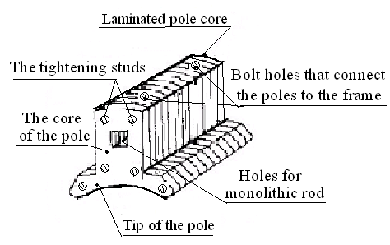 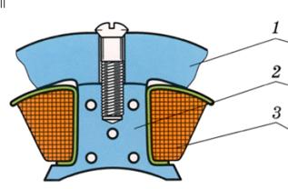

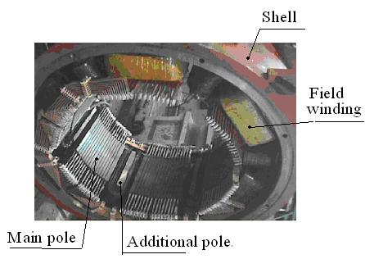

**Fig. 5.2 – Main Poles**

1 – bed. 2 – pole core. 3 – field winding

The core of the main pole is assembled from sheets of electrical steel. Sheet thickness 2-3 mm.

**The main poles create the working field of the machine**

**Construction of the DC machine field winding.**

The field winding of the DC machine is made of coils (copper wire) wound on the pole, so that when the current passes, poles with opposite polarity are created.

The field current generates an electromagnetic field inside which the anchor of the DC motor rotates. EMF is induced in the conductors of the anchor winding by the current flux of field winding.

2) **Anchor of DC machine (rotor) - part of the machine that rotates**.

### An anchor consists of a shaft; of a core, in the grooves of which the anchor winding is laid and of the collector. The collector is the main element of the machine. An anchor winding ends are attached to it. Collector is a mechanical rectifier in the generator mode and is a mechanical inverter in motor mode.

### Construction of the DC machine anchor core and anchor winding

The DC motor anchor is a rotating part of the machine. The magnetic field of the field winding (main field) in the conductors of the armature winding induces an EMF, because the main field for the armature windings is variable. This alternating field creates magnetic losses. Therefore, the anchor core is made of thin steel plates to reduce magnetic losses, such as hysteresis and eddy current losses, respectively. These laminated steel sheets are stacked together to form the cylindrical structure of the anchor core.

The anchor core has grooves in which the anchor winding is placed; they are evenly distributed over the anchor.

The anchor winding in the grooves fixes with wedges so that it **do not** **fall out** of the grooves due to the action centrifugal force.

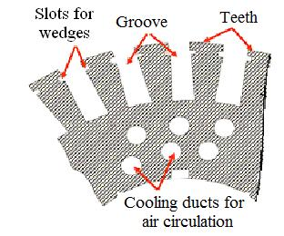Anchor winding consists of copper wire coils.

The anchor winding ends attached to the “**cockerels**” of the collector. Frontal sections of the sections are fastened with bandages. Bandages make of steel wire or glass tape.

**Anchor winding of a DC machine can be of various types:**

1) Simple and complex windings.

2) Multi-way winding.

Fig. 5.3 – The DC machine anchor plate core

Simple windings are wave, loop and combined (sometimes they are called "frog").

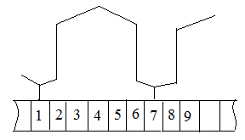 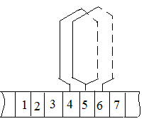 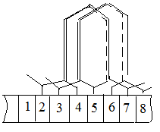

*a b c*

Fig. 5.4 – The schemes of DC machine anchor winding

The combined winding **is the sum** of the wave and loop windings.

**Anchor winding parallel branches**

The most important difference of windings is the number of parallel branches. Simple wave windings have two parallel branches (*a* = 1) always, where *a* is the number of pairs of parallel branches (fig. *a*).

Simple loop windings have the number of parallel branches *a*=*p*, (***a*** is equal to ***p***) where ***p*** is the number of pole pairs of the machine (fig. *b*).

Combined windings are the sum of a simple wave winding and *a* simple loop winding. In these windings *a*=*p*, due to the presence of a loop winding (fig. *c*).

**Complex windings have two and three strokes.**

**Leveling conductors**

In the manufacture of machine designs, asymmetry occurs. Therefore, in the parallel branches of the windings may be different currents. These currents must be equalized before coming into the collector. To do this, use **leveling** **conductors**.

Only for wave windings do not use **leveling conductors**, because they have only two parallel branches. And different currents in the wave windings are aligned along this winding.

**Therefore, the choice of anchor winding always begins with a simple wave winding**.

If you want to increase the number of parallel branches of the anchor winding, use loop or combined winding. In combined winding leveling conductors do not use because it has the wave sections and different currents are aligned along the winding.

An increase in the number of parallel branches may be necessary to reduce the current of a parallel branch

.

**But it is tentative.** Но это предварительно

**Finally**, the type of anchor winding is determined by two conditions:

1) The voltage between the collector plates should be not more than 17-18 V. If the voltage is large, a fire will occur around the collector ("**circular fire on the collector**");

2) The thickness of the collector plates must be more than 3-3.5 mm.

**Construction of] collector (commutator) of DC machine**

**The collector** designed to convert the variable current into a constant (in the generator) and direct current to an alternating current (in the motor).

The main elements of the collector are copper collector plates. The lower part of the collector plates has the form of a "swallowtail". The collector plates are isolated from each other and from steel washers by mikanite gaskets.

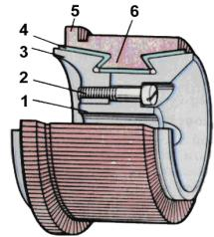 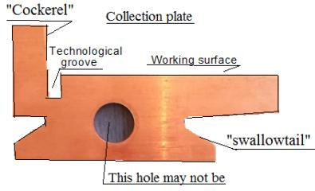

Fig. 5.5 – **Collector with conical washers**

1 – front pressure cone; 2 – the screw; 3 – rear pressure cone; 4 – isolation from

mikanite; 5 – the cockerel of the collector plate; 6 – collector plate

The upper part of the collector plates called the "cockerel". Narrow longitudinal grooves are make in the cockerel. The ends of the anchor winding place in this grooves and soldered there.

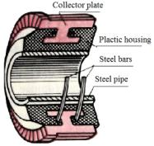 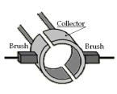

Fig. 5.6 – Segment of plastic collector and brush of DC motor

The collector of a DC machine is a cylinder that is assembled from collector plates. Micanite insulate plates.

**The function of Collector**

Consider a frame that rotates in the magnetic field of permanent magnets. The ends of the frame are attached to the ring. For simplicity, we draw one ring, Fig. 5.8, *a*. After that, we cut the ring into two, Fig. 5.8, *b*. In this case, the lower parts of the sinusoid are not inducted.

|  |  |
| --- | --- |
| *a b c* | *a*)  *b*)  c)  d) |

Arrange another frame at an angle of 90 el. degr. to the first frame. We cut the ring into 4 parts and attach the end of the frame to each part of the ring, Fig. 5.7, *c*.

If we continue to add frames and cut the ring, the current will approach a constant value, Fig. 5.8, *d*.

**Conclusion**: the collector in the generator is **a mechanical rectifier**.

In the real case, frames are placed in the grooves of the anchor core - these are the conductors of the anchor winding. And the ring, which we cut into parts – it’s collector.

**Construction of Brushes of DC Machines**

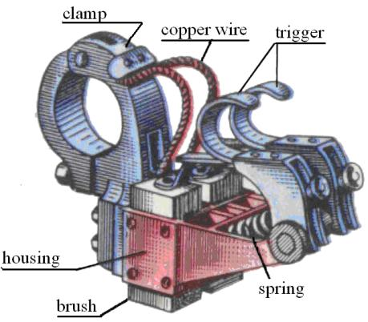Brushes of DC machines are made of carbon or graphite materials. They provide sliding contact between the rotating collector and the brushes. In the engine mode, brushes are used to transfer current from an external circuit to the armature winding through a rotating manifold. Brushes install in special devices (brushes holders).

**A fan** on the shaft is needed to cool the machine.

Fig. 5.7 - **DC machine brush holder**

1 – trigger. 2 – spring. 3 – brush.

4 – housing. 5 – clamp; 6 – copper wire

**Consider the principle of the operation of a DC machine in generator mode.**

A direct current flows in the winding of the main poles and creates the main magnetic field of the machine. The motor rotates the anchor of the machine. During rotation, the constant field of the main poles becomes variable for the armature winding. An EMF is created in the conductors of the anchor winding according to the law of electromagnetic induction.

When the generator is turned on to the load, current appears in the anchor winding.

**The principle of the operation of a DC machine in the engine mode**

A direct current flows in the winding of the main poles and creates the main magnetic field of the machine, as in the generator mode. The DC current goes to the anchor winding through the brushes and the collector. The magnetic field of the anchor tries to form with the magnetic field of the main poles. Engine torque appears.

The alternating current is in the anchor windings, Fig. 5.8, where *ia* – the armature current of parallel branch, А; *Tk* – the switching period (switching) of the armature winding from one parallel branch to another.

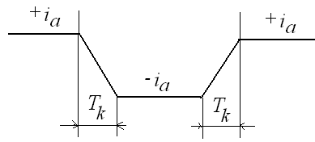The parallel branch of the anchor winding is a group of armature winding sections in which the current has the same direction

In the engine mode, a constant current is applied to the anchor.

Fig. 5.8 – The commutation process

The collector turns it into an anchor alternating current. The alternating magnetic field of the anchor current interacts with the field of the main poles and creates a torque that rotates.

**It's a motor.**

**Conclusion: the collector in the motor mode is a mechanical inverter**

**Calculation of the magnetic circuit of a DC machine**

The magnetic circuit of the DC machine is the path through which the magnetic field line passes. The magnetic circuit is divided into separate sections. Each section has the same cross-section and material.

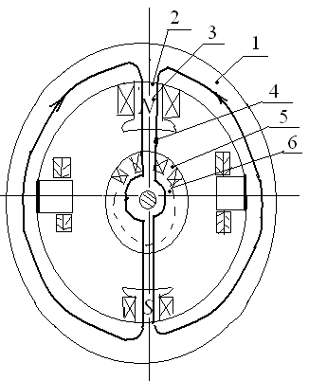Calculate the magnetic circuit – this means to determine the magnetic force of the main poles *Fr* = *ir*·*wr*.

Fig. 5.9 – The magnetic

circuit of the DC machine

*FΣ* = , А

1 – bed; 2- the junction of the main pole and the bed;

3 – the main pole; 4 – air gap; 5 – anchor teeth; 6 – Anchor back.

Calculation of the magnetic force is carried out for each site. We consider that the value of the nominal magnetic flux, the cross sections and the length of the lines of force of all six sections.

For *i* = 2 and 4 (air gap) the calculation is carried out according to this algorithm:

, Tl , A; , A;

*ka* – the air gap coefficient (Carter coefficient), which takes into account the presence of slots at the anchor.

Usually, Ossana's formula is used to calculate the air gap coefficient

.

*tz* – anchor tooth division by outer diameter of anchor;

*bz* – the width of the anchor tooth by the outer diameter of the anchor.

*hz* – anchor tooth height

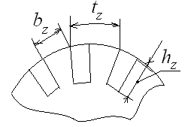

All other areas (steel) are calculated by one algorithm:

; Then to the tables we find the strength of the magnetic field by value of induction in each section according *H*1,3,5,6 =*f*(*B*1.3.5.6).

The magnetic force at each site *F*1,3,5,6= *H*1,3,5,6·*l*1,3,5,6, A

Now determine the total magnetic force *FΣ* = , А, current and number of turns of the field winding *FΣ* = *ir·wr*.

**The anchor reaction in DC machines** – this is the effect of the magnetic flux *Фar*, which is created by the current of the anchor, on the characteristics of the machine and the flux of the main poles. The reaction flux of the anchor *Фar* is directed perpendicular to the main flow of the machine *Фr*.

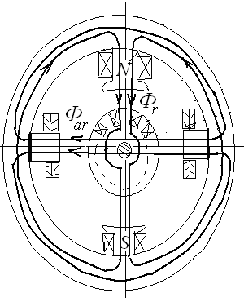 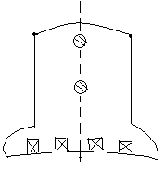

Fig. 5.10 – The anchor reaction in DC machine. Fig. 5.11 – A compensating winding

**The reaction flux of the anchor has an effect**:

1) Makes the main magnetic flux of the machine less (weakens);

2) Spoils the shape of the magnetic field below the main poles. It can cause a circular fire on the manifold.

To combat the influence of the reaction of the anchor, additional poles and a compensating winding are used. The compensating winding is placed in the slots that make in the tips of the main poles.

**Commutation in DC machines**

This is the main problem in DC machines.

**Commutation** is the process of switching the armature winding sections from one parallel branch to another. In this case, there is often sparks.

To improve the Commutation:

1) use additional poles;

2) reduce reactive EMF, which is induced by scattering fluxes in the armature winding. By the formula of Pihelmayer

*er* = 2·*As*·*la*·*Va*·*wa*·Σλ*i*, V.

where *As* – linear load. Machines with less load commute better;

*la*– anchor length. Short machines commute better;

*Va* – anchor linear velocity. At a lower speed, commutation is better;

*wa* – number of turns of the anchor winding. One-winding windings should be selected;

Σλ*i* – the sum of the conductivities of the scattering fluxes.

3) Application of shortened anchor winding.

4) The use of certain brushes.

**Schemes for the inclusion of field windings in DC machines**

For DC electric machines, 4 circuits of excitation windings are used: parallel, sequential, mixed, independent. Generators do not use sequential excitation.

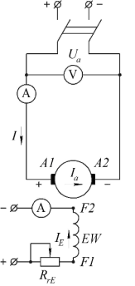 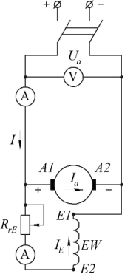 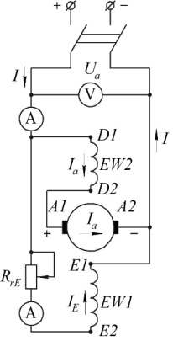 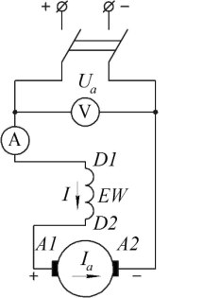

|  |  |  |  |
| --- | --- | --- | --- |
| *а* | *b* | *c* | *d* |

Figure 5.12 - Wiring excitation windings of the DC machines

*a* – independent excitation; *b* – parallel excitation; *c* – mixed excitation;

*d* – consecutive excitation

**The basic equation of the DC generator**

*Uа* = *E* - *Ia·Rmc*

where *Uа* – the voltage that is applied to the anchor of motor;

*E* – EMF, which is induced in the anchor winding; *Ia* – anchor current;

*Rmc* – main circuit resistance of the anchor.

*Rmc* = *Ra* + *Rap* + *Rcw* + *f*(*Rfw*)

*Ra* – the resistance of the anchor winding;

*Rap* – the resistance of the additional poles;

*Rcw* – the resistance of the compensating winding;

*f*(*Rfw*) – resistance of the field winding, taking into account the circuit of its activation.

**The basic equation of the DC motor**

*Uа* = *E +* *Ia·Rmc*

For the motor, the calculation of the voltage is not very important. It is necessary to know the frequency of rotation. We will carry out calculations:

*E = Uа* - *Ia·Rmc*

*E = СЕ·Фr·n,*

where *СЕ* – constant factor for the machine: *СЕ* = 

*Фr* – magnetic flux of main poles

*na* – rotation frequency ofthe anchor

*СЕ·Фr·n* = *Uа* - *Ia·Rmc*

.

**Methods for adjusting the frequency of rotation of the DC motor**:

The regulation of the motors speed with different circuits of the excitation winding is possible due to a change in three quantities: the main magnetic flux *Ф*, the resistance of the main circuit of the anchor winding *Rmc*, the supply voltage of the motor *Ua*. Therefore, three ways of adjusting the rotational speed are distinguished:

1) **Regulation of the flux main poles** *Ф*. It is possible to increase and decrease the speed of rotation. This is the main and most economical way of regulation, since regulation is carried out by introducing rheostats into the excitation winding circuit, which consumes only a few percent of the engine power;

2) **Regulation of the main circuit resistance** *Rmc*. This method is associated with large energy losses in the rheostat, which is included in the electrical circuit of the armature winding. This reduces the efficiency of the machine. With this method, the speed is adjusted only downward from the nominal value by introducing additional rheostats;

3) **Regulation of the voltage** *Uа*. This method is economical and depends only on the selected power source that is used in the circuit. The efficiency of the engine changes slightly. Due to the fact that increasing the voltage in the armature circuit above the nominal value is dangerous, this method only allows decreasing the speed of rotation *n*. It should also be remembered that when the voltage decreases, the starting torque of the motor proportionally decreases.

**The variation of DC motor speed characteristics**

Speed characteristic is the dependence of the rotation frequency of the anchor on the current of the anchor (on the load) *n* = *f*(*Ia*).

Equation speed characteristics:

, rpm.

Characteristics are called natural if they are constructed for the nominal values of voltage and magnetic flux, and also in the absence of additional resistances in the armature circuit. If each of these conditions is violated, the characteristic is considered to be artificial.

The type of speed characteristic depends on the circuit of the excitation winding. Let us construct the speed characteristics *n* = *f*(*Ia*), where *Ia* is the anchor current, which determines the load value.

1) Motors with independent excitation have a fairly rigid characteristic (Fig. 5.13).

When the load increases, its speed decreases a little, only because of the voltage drop in the elements of the electrical circuit. With this scheme, it is possible to regulate the current in the excitation winding so that the value of the main-pole current is constant (*Φ* = const) and does not change due to the demagnetizing effect of the anchor reaction flux.

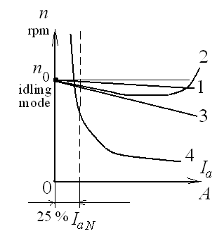

Figure 5.13 – Speed characteristic of a DC motor

1 – for a motor with independent excitation; 2 – for a motor with parallel excitation;

3 – for the engine with mixed excitation; 4 – for a series-excited motor

Such excitement is used for the most powerful machines. There are large currents and voltages in the anchor winding of the machines of high power. Therefore, the regulation of the engine speed and reverse is performed along the excitation winding circuit. In the excitation winding circuit, the current and voltage are less. Therefore, the control can be performed along the excitation winding circuit.

2) For engines with parallel excitation (line 2) the speed of the anchor is first reduced because of the voltage drop in the elements of the electrical circuit. Then the demagnetizing effect of the anchor reaction flow begins to act. The speed of the anchor decreases less. And from some point it even begins to increase.

.

This change in speed limits the use of motors with parallel excitation.

Usually these are low-power engines. They are used for driving metal-cutting machines, for conveyors, fans, etc.

3) For motors with mixed excitation (line 3), the anchor rotation frequency decreases evenly. As the load increases, the action of the anchor reaction flow increases. It reduces the main flux of the machine. But at the same time, the additional flux that is generated by the current in the series winding also increases. This makes the total magnetic flux constant.



where *Фap* – magnetic flux from the winding current, which is connected in series with the anchor winding.

Uniform reduction of the rotational speed makes it possible to use machines with mixed excitation for many mechanisms of medium power. Such machines are used most often.

4) For motors with sequential excitation (line 4) the speed of rotation of the anchor varies from the load on the hyperbolaе.



In motors with sequential excitation *Ф* ~ *Ia*.

Therefore *na*~,

where , .

Characteristics of the engine with series excitation allow you to easily and quickly adjust the speed of rotation in a wide range.

Therefore, motors with sequential excitation are used where idling is impossible and it is necessary to change the speed of rotation quickly. For example, they are used in electric transport (tram, trolley, underground, electric trains).

**Requirements for the operation of DC motors**:

1) For motors with independent, parallel and mixed excitation, the excitation winding is not cut off when operating in the nominal mode. At the same time, the speed of rotation of the armature increases sharply - this is an accident.

2) Engines with series excitation should work with a load of at least 25% of the rated value.

**Start of DC motors**

When starting the engine, you must:

1) Ensure a large value of the starting torque;

2) limit the magnitude of the starting current;

3) Use simple methods and equipment for starting engines.

**There are three ways to the engine start:**

1) direct starting at rated voltage.

**The direct start with rated voltage** is only used for small DC motors with a power of up to hundreds of watts.

When starting small DC motors *na*=0, *Ea*=0, *IaN* = *Ua*/*Raw*. In low-power engines, the resistance of the main circuit of the armature winding *Raw* is relatively large, the duration of the start does not exceed 1-2 sec. Therefore, when the starting current is increased to *Iast* = 10÷20 *IaN*, its value does not have time to damage the insulation of the winding;

2) **start-up using** **with** **a starting rheostat**, which is connected in series to the anchor winding circuit. This is the most common way to start a DC motor.

With we use this starting method, a sufficiently high starting torque obtain and the starting current of the anchor is limited.

When DC motors start (*n*=0), the armature current is very large, because the resistance of the armature winding *Raw* is small. Therefore

*Iast* =.

It is unacceptable. The permissible inrush current value can usually be, for example, *Iast* = 2 *IaN*.

When it is necessary to add a starting rheostat to the armature winding

*Iast* =. *Rreos*=.

The resulting value of *Rreos* is divided into several stages. For example, *Rreos* is divided into threestages.

Resistance of one stage of the rheostat *R= Rreos*/3. The engine is started with a gradual decrease in the number of stages of the rheostat.

3) **Starting the engine when reducing the voltage** of the armature winding *UaN*.

*Iast* =.

Start-up with lowered voltage is performed, if there is a regulated voltage source in the enterprise.

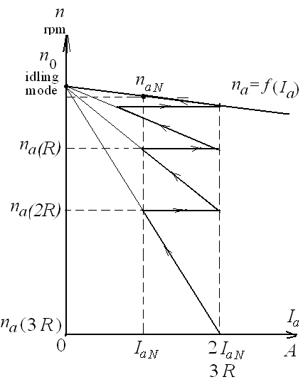**DC motor speed control**

Figure 5.14 – Start the DC motor with the help of starting rheostats

The speed of a DC motor can be adjusted in several ways. We write the basic equation of the constant current motor

$n_{a}=\frac{U_{a}-I_{a}∙R_{a}}{C_{E}∙Φ}$ $n_{a}=\frac{U_{aN}-I_{a}∙R_{a}}{C_{E}∙Φ}$, rpm

were *UaN* – nominal voltage of anchor, V

*Ia* – current of anchor winding (load current), A

*Ra* – main circuit resistance, Ohm

Ф – main motor flux generated by field current

CE – coefficient "machine constant"

$C_{E}=$*CE*=(*p∙Na*)/(60∙*a*)

*p* – number of pole pairs

*Na* – number of armature winding conductors

*a* – the number of pairs of parallel branches of the armature winding (depends on the type of winding). If the winding is wave *a*=1, if the winding is loop or combined, then *a*=*p.*

1) **Voltage change**. Voltage can only be reduced. Moreover, the speed of a DC motor can only be reduced.

2) **Additional resistance can be added to the armature winding**. Speed can only be reduced. They are not used because they increase resistance and increase electrical losses.

3) The main way is **to regulate the main flux of engine**. The main flux can be changed by changing the current in the field winding, (in the winding of the main poles).